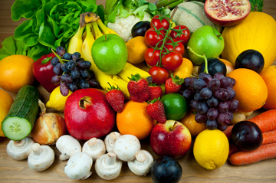

**CS5591 Advanced Software Engineering**

**Calorie 2 Grocery**

**Increment#3 Report**

**Project Group #12**

**Team Members**

Sravani Punyamurthula

Vaishnavi Aienampudi

Leela Naga Devi Gajula

Vinaya Podduturi

**Project Goal:**

The goal of our project is to develop an android application “Calorie2grocery”, which helps its users to plan for a proper meal to maintain healthy life style. Firstly, it provides the calorie count of a recipe. The app has a browser which allows the user to import a recipe and get a list of ingredients. The app then displays the calorie count for each ingredient in the recipe. Each user has his/her own specifications and preferences for recipes. Hence the app provides its users with an option to edit the ingredient list. Users can add or remove ingredients and can get the total calorie count of that recipe. The calorie count helps its users to take healthy choices about their meal. Secondly, it automatically generates a shopping list so that the user does not miss anything that he needs to buy. It provides us the flexibility to log the groceries available at our home. Our app will generate alert notifications about the expiry dates of groceries which in turn helps in reducing the wastage of food. Based on the recipe chosen it, prepares the list of ingredients to buy in order to prepare the recipe. Thus the app functions as a unified meal planner which takes care of grocery management as well as provide calorie information to plan for a healthy meal.

**Increment #3**

In Increment#2, we have developed an application which allows the user to a) Add grocery items available at their home to the database and view the list b) Search for a recipe and import the ingredients in the recipe.

In Increment3 we have added the following features to the application:

1. Update the quantity of grocery items
2. Delete the grocery items from the list
3. Create a recipe and store the recipe in the database
4. Share the recipe through Facebook and twitter
5. Add/Remove ingredients from recipes
6. Send notifications to users about the expiry date of recipes
7. Get calorie information for each ingredient of the recipe

**Application Specifications:**

|  |  |
| --- | --- |
|  | **Tools** |
| Platform | Android 4.0.3 |
| UML Diagrams | Microsoft Visio |
| Languages | Java, C# , ASP.Net , JQuery , JavaScript , AJAX |
| Database | SQL Server |
| Planning | ScrumDo |
| Version Control System | GIT |
| Existing Rest Services | Recipe Search  Calorie API |
| New API’s | Grocery list - Added Update, Delete methods  Import API – Added Add, remove ingredient methods |

**Existing Services:**

1. **Recipe Search & Diet API :**

This API provides services for the following:

* Nutritional Analysis
* Recipe Search

We are using Recipe Search and Diet API to search for a recipe. This API provides information about the ingredients, the preparation time and procedure for a recipe. This API provides detailed information about the quantity of ingredients, total calorie count of the recipe etc. Also this API provides additional search capabilities like we can include restrictions on allergic items etc. Hence we are using this API to get the list of recipes based on a keyword and import the ingredient list.

API: <https://api.edamam.com/search?q=chicken&app_id=51aba909&app_key=9fcd3aa5746d2a423a350cee3ea4d57d>

Reference: <https://developer.edamam.com/>

1. **USDA Nutrition API :**

NDB is the nutrition database provided by the United States Department of Agriculture. Each food item is assigned a NDB number. We can fetch the calorie information any ingredient only by knowing the NDB No.

The following API fetches the NDB No. of a food item. Ingredient name is passed as parameter to this url:

<http://api.nal.usda.gov/usda/ndb/search/?format=json&q=spinach&sort=n&max=1&offset=0&api_key=DgxqZYmXG8YsyCIEfFLkJaAklM4ybQtEHORaKedx>

The following API accepts NDB No. as an input and fetches the calorie information:

<http://api.nal.usda.gov/usda/ndb/reports/?ndbno=03127&type=b&format=json&api_key=DgxqZYmXG8YsyCIEfFLkJaAklM4ybQtEHORaKedx>

For increment#3, we are displaying the calorie count per serving of the ingredient. We need to enhance the logic to take the quantity of the ingredient and display the exact calorie count in the final increment.

**New Services:**

We have created 2 rest services for implementing the server side logic for this application.

1. **Grocery List**: This API is used to maintain the grocery lists. We added two methods to this API.
2. **Delete Grocery Item:** This method is used to delete grocery items from the grocery list. We need to provide name as an input to the API URL.

API: <http://kc-sce-cs551-2.kc.umkc.edu/aspnet_client/MPG12/Sravani/viewGrocery/Service1.svc/deleteGrocery/Sravani/butter>

1. **Update Grocery Item:** This method is used to update the quantity & units of a grocery item. We need to pass the name, quantity & units as input to the URL.

API: <http://kc-sce-cs551-2.kc.umkc.edu/aspnet_client/MPG12/Sravani/viewGrocery/Service1.svc/updateGrocery/Sravani/butter/30/gm>

1. **Import Recipe:** This API is created to import the recipe information from the recipe search API and store the recipe name and ingredient list in the database. We added two methods to this rest service.
2. **Add Ingredient:** This method is used to add ingredients to the recipe based on user’s taste preference.

API: <http://kc-sce-cs551-2.kc.umkc.edu/aspnet_client/MPG12/vinaya2/RecipeIngredient/Service1.svc/data/>

1. **Remove ingredient:** This method is used to remove any of the ingredients from the recipe.

API:

**Use Case Template to update grocery item:**

|  |  |
| --- | --- |
| **Use Case Name** | Update grocery items |
| **Primary Actor** | User |
| **Pre-Conditions** | 1. User has the app installed on his/her mobile. 2. User should be logged into the app. |
| **Guarantee(Post Conditions)** | Quantity of grocery items is updated in database. |
| **Main Success Scenario** | 1. User clicks on “View/Edit grocery list” button in the home page. 2. The system transitions the UI to the “View Grocery” layout. 3. System fetches the grocery list of the user from the database. 4. User clicks on the quantity of the grocery item he/she needs to update. 5. System changes the quantity cell to editable mode. 6. User updates the quantity and hits enter. 7. System updates the data in the remote database. |
| **Extensions** | 3a. User clicks the units cell of the grocery item.  4a. System changes the units cell to editable mode.  5a. User updates the unit for the grocery item.  6a. System updates the measure of the grocery item in database. |

**Use Case Template to delete grocery item:**

|  |  |
| --- | --- |
| **Use Case Name** | Delete grocery item |
| **Primary Actor** | User |
| **Pre-Conditions** | 1. User has the app installed on his/her mobile. 2. User should be logged into the app. |
| **Guarantee(Post Conditions)** | Grocery item is deleted from the database. |
| **Main Success Scenario** | 1. User clicks on “View/Edit Grocery List” button in the home page. 2. The system transitions the UI to the “View Grocery” layout. 3. System fetches the grocery list of the user from the database. 4. System displays the grocery list to the user. 5. User can click on “Edit” button 6. System display minus sign in front of each grocery item in the list. 7. User clicks on the minus sign in front of the grocery item he/she wants to delete. 8. System opens an alert dialog asking the user to confirm deletion. 9. User hits “OK”. 10. System deletes the grocery item from the database. 11. System removes the row in the display |
| **Extensions** | 9a. User hits “Cancel”.  9b. System doesn’t delete the grocery item. |

**Use Case Templates for Add Ingredient to a recipe:**

|  |  |
| --- | --- |
| **Use Case Name** | Search & import a recipe |
| **Primary Actor** | User |
| **Pre-Conditions** | The user must be a valid user to use the app |
| **Post-Conditions** | Retrieves the results for the search |
| **Main Success Scenario** | 1. If the user wants to search for a recipe, then, the user enters the keyword to search. 2. User clicks on the search recipes. 3. The system displays ten recipe names. 4. If the user wants to see the ingredient list, then the user can click on the recipe name. 5. System displays ingredient list along with quantity. 6. If the user wants to import the ingredient list then click on import. 7. The system stores the ingredient list in the database. |
| **Extensions** | User can view and update the recipe |

**Use Case Templates for View Favorite Recipe:**

|  |  |
| --- | --- |
| **Use Case Name** | View recipe |
| **Primary Actor** | User |
| **Pre-Conditions** | The user must be a valid user to use the app |
| **Post-Conditions** | Retrieves the results for the search |
| **Main Success Scenario** | 1. If the user wants to get the favorite recipe then user clicks the view favorite recipe button 2. User clicks on the favorite recipes. 3. User gets all the favorite recipe list from the database. |
| **Extensions** | User can update the recipe |

**Use Case Templates for Update Favorite Recipe:**

|  |  |
| --- | --- |
| **Use Case Name** | View recipe |
| **Primary Actor** | User |
| **Pre-Conditions** | The user must be a valid user to use the app |
| **Post-Conditions** | Retrieves the results for the search |
| **Main Success Scenario** | 1. If the user wants to get the favorite recipe then user clicks the recipe name. 2. User clicks on the get recipe button 3. User gets all the recipe name, ingredient list , quantity and label from the database. 4. User can add, remove, update the ingredient , quantity and label 5. User can click the update button. 6. System uploads the changed the recipe list to the database. |

**Use Case Templates for Create Favorite Recipe:**

|  |  |
| --- | --- |
| **Use Case Name** | View recipe |
| **Primary Actor** | User |
| **Pre-Conditions** | The user must be a valid user to use the app |
| **Post-Conditions** | Retrieves the results for the search |
| **Main Success Scenario** | 1. If the user wants to create the favorite recipe then user enters the recipe name , ingredients list and their quantity and labels. 2. User clicks on the add more button for more ingredients to the recipe. 3. User adds all the ingredients and quantity and their labels and clicks the save recipe button. 4. System uploads the recipe tot the database. |
| **Extensions** | User can Share the recipe in twitter and facebook. |

**Use Case Templates for Share Favorite Recipe:**

|  |  |
| --- | --- |
| **Use Case Name** | View recipe |
| **Primary Actor** | User |
| **Pre-Conditions** | The user must be a valid user to use the app |
| **Post-Conditions** | Retrieves the results for the search |
| **Main Success Scenario** | 1. If the user search for the recipe . 2. User gets the ingredients list, quantity and label for the recipe. 3. User can share the recipe in the twitter. 4. User can share the recipe in the facebook. |

**UML CLASS DIAGRAM:**



Figure 1: UML Class Diagram of the entire system

**Activity Diagram for the functionality implemented in Increment 3:**



**Sequence Diagram:**



Figure 3: Sequence Diagram

**Increment#3 Implementation:**

1. **Implementation of User Interface:**

We have grouped the functionalities and developed 3 new layouts as part of UI implementation.

1. Home Page
2. My Groceries : Once we go to My groceries page, there are 2 options:
3. Add Grocery
4. View/Edit Grocery (Enhanced the functionality in this page to update/delete the grocery item
5. Recipes: We have created two buttons in this page:
6. Search Recipe ( Added functionality to add/remove ingredients and display calorie information of each ingredient)
7. Create Recipe (User can create his/her own recipe and save it to the database)
8. Share Recipe (User can share recipes through Facebook or twitter.
9. Show Notifications: This page posts notifications to the user about the expiry dates of the grocery items.

**Screenshots:**

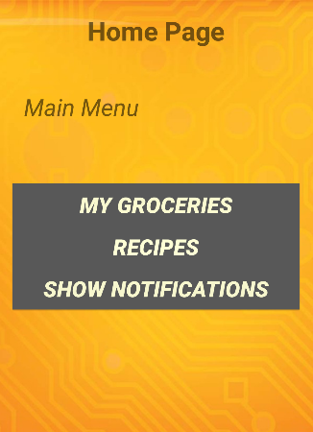

**Home Page**

User is provided with three buttons:

* My Groceries: User can click this button

For managing his grocery list.

* Recipe: User can click this button to search for recipes or create recipes.
* Show Notifications: User can click this button to view the notifications.

Screenshot 1: Home Page

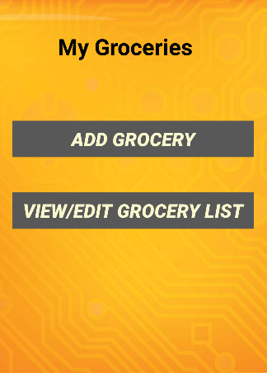

**My Groceries**

* When the user clicks on My Groceries button in the home page, the UI is transitioned to My Groceries page.
* User can add grocery items by clicking on Add Grocery button.
* User can view the grocery list, edit the quantity of the grocery items, and delete the grocery items by clicking on View/Edit grocery List.

Screenshot 2: My Groceries page

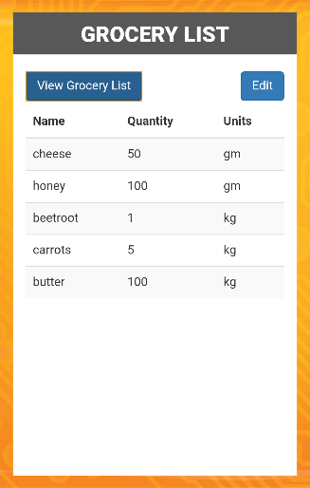

**View/Edit Grocery List**

* User can click the View grocery list button to view the grocery list.
* System fetch the grocery information from the remote database and displays it to user.

**Technical Details:**

* We have created a web service to retrieve data from the remote database
* We have used Ajax function to call the API and display the data
* Used twitter Bootstrap styling for table.

Screenshot 3: View/Edit Grocery page

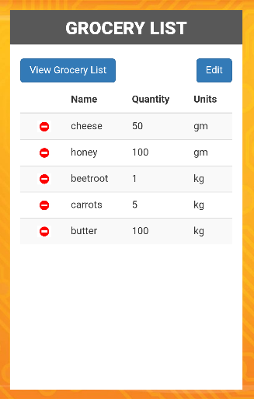

**View/Edit Grocery List**

* User clicks on “Edit” button to delete grocery items from the list.
* System displays “Minus” sign in front of every grocery item.
* User needs to click on the “Minus” sign to delete a grocery item.

**Technical Details:**

* We have implemented the client logic using Jquery.

Screen shot 4: Edit Grocery

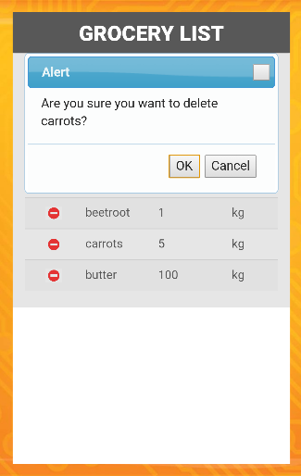

**View/Edit Grocery List**

* User clicks on the “Minus” sign in the “Carrots” row to delete carrots from grocery list.
* System displays an alert dialog asking the user to confirm.
* User can click on “Ok” to delete or “Cancel” to cancel the deletion.

**Technical Details:**

* Implemented the alert dialog using JQuery UI.

Screen shot 5: Delete grocery alert

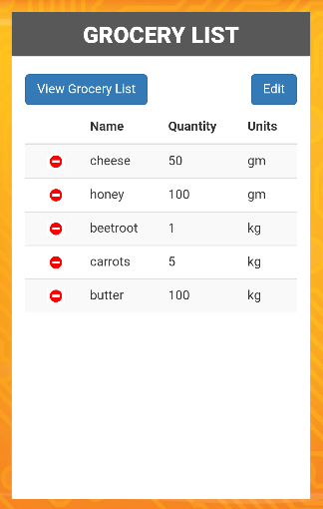

**View/Edit Grocery List**

* If the user clicks on “Cancel” button in the alert dialog then nothing happens.

Screen shot 6: Delete Grocery

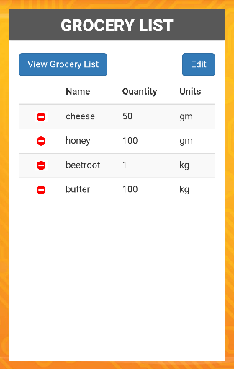

**Delete Grocery**

* Once the user clicks on “Ok” button in the alert dialog, grocery item “Carrots” is deleted from the list

**Technical Details:**

* We have created a rest service for deleting the grocery item in the remote database.

Screen shot 7: Delete Grocery

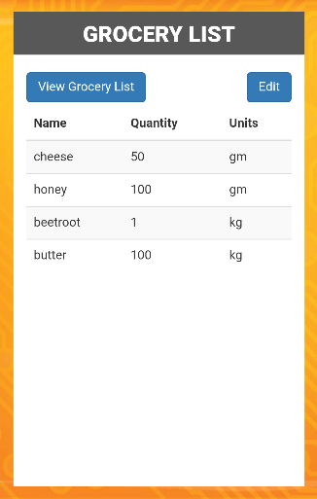

**View Grocery List**

* Once the user clicks on View Grocery List button within the page, the page comes out of the editable mode and refreshes the grocery list.

Screen shot 8: View Grocery list

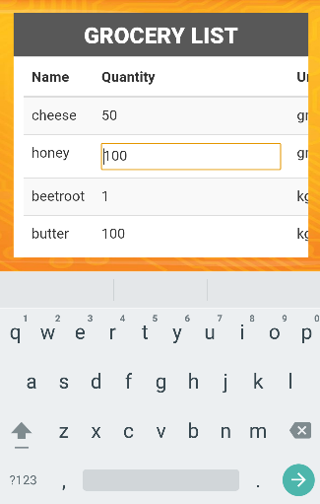

**Updating Quantity**

* User can click on any quantity/units cell of any grocery item row to update.

Eg: The screen shot shows that after clicking the quantity cell of Honey, the cell is changed to editable mode.

**Technical Details:**

* The client side logic is implemented using web technologies JavaScript, Jquery & Ajax
* Used bootstrap style sheets.

Screenshot 9: Update Grocery

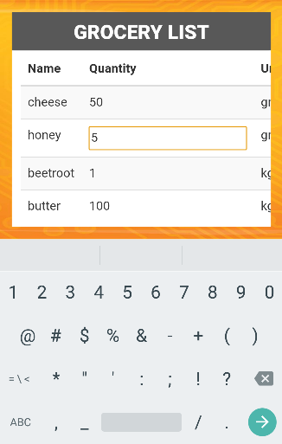  
 Screenshot 10: Update Grocery

**Updating Quantity**

* User can change the quantity and hit enter. Eg: changed the quantity of honey from 100 to 5.
* In a similar manner, he can click on the Units cell of any grocery item and update it.

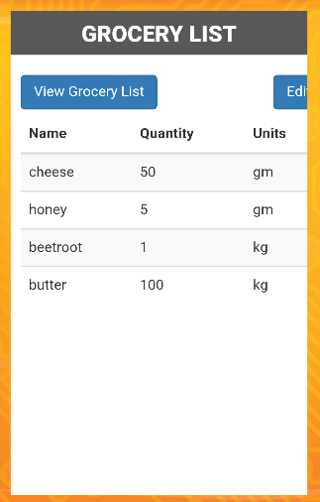

**Update Quantity**

* The quantity of the grocery item “honey” is changed to 5.

**Technical Details:**

* We have created a update grocery method in the rest service.
* We have used Ajax function to call the API and update the data in the database.

Screenshot 11: Update Grocery

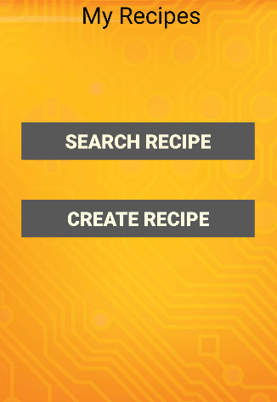

**Recipes Page**

* If the user clicks on the “Recipes” button in the home page, then the UI is transitioned to My Recipes page.
* There are two buttons in this page, one to search for recipes, the other to create their own recipe.

Screenshot 12: Recipes Page



**Search Recipes Page**

* If the user clicks on the “Search Recipes” button in the Recipes page, then the UI is transitioned to Search Recipe page.
* User can enter in the recipe name in the input box and enter Go!.

**Technical Details:**

* We have used bootstrap to style the input control with a placeholder for this page.

Screenshot 13: Search Recipe

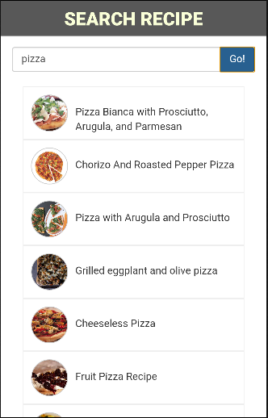

**Search Recipes Page**

* In this screenshot, the user entered “Pizza” in the input box and hit Go.
* System displays list of recipes for Pizza.

**Technical Details:**

* We have used Ajax to make calls to the rest service in order to fetch the recipes.

Screenshot 14: Search Recipe

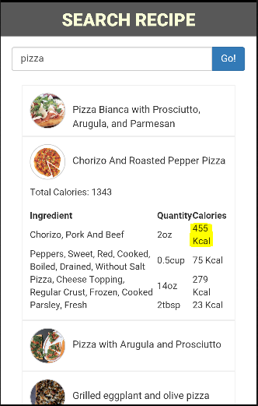

**Search Recipes Page**

* To get the ingredients required for a recipe, user can click on any recipe name in the list.
* System displays the list of ingredients along with their calorie information
* System displays the total count of calories for the recipe.

**Technical Details:**

* To get the calorie information for each ingredient, we are making two Ajax calls to USDA NDB database.
* The first call gets the ndb_no for the ingredient
* The second calls gets the ingredient calories based on the ndb_no.

Screenshot 15: Ingredients with calorie info

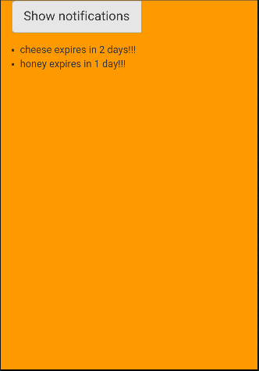

**Notifications Page**

* Once the user clicks on the “Show Notifications button on the home page, UI is transitioned to this page.
* System displays the alert messages related to the expiry dates of the grocery items.

**Technical Details:**

* We have used a rest service to get the expiry date information of the grocery items from the database.

Screenshot 16: Notifications

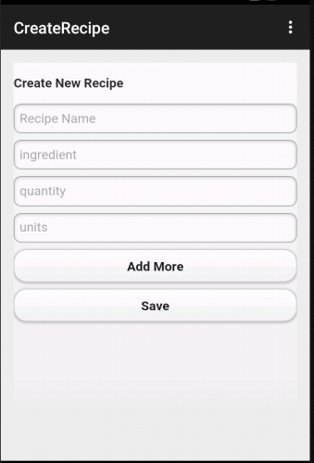

**Create Recipe Page**

* User can create a new recipe by entering the recipe name, ingredients along with quantity and units.
* Add more: This button lets the user to add more ingredients along with quantity and units.
* Save: Used to save the created recipe.

Screenshot 17: Create Recipe

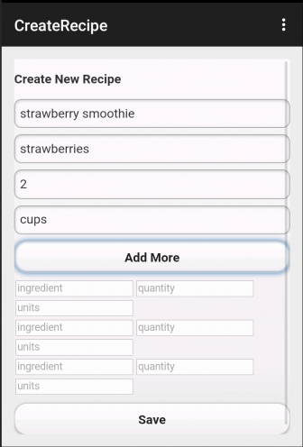

**Create Recipe Page**

* This screenshot shows creating Strawberry Smoothie recipe using the application.

Screenshot 17: Adding ingredient

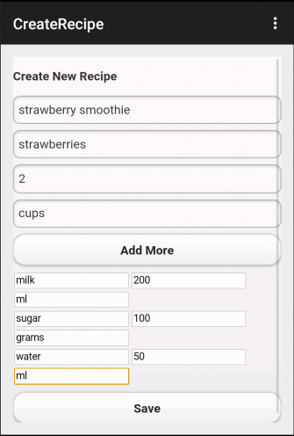

**Create Recipe Page**

* Add more: This button lets the user to add more ingredients along with quantity and units.
* The screen shows adding additional ingredients milk, sugar, water to the recipe.

Screenshot 17: Adding more ingredients

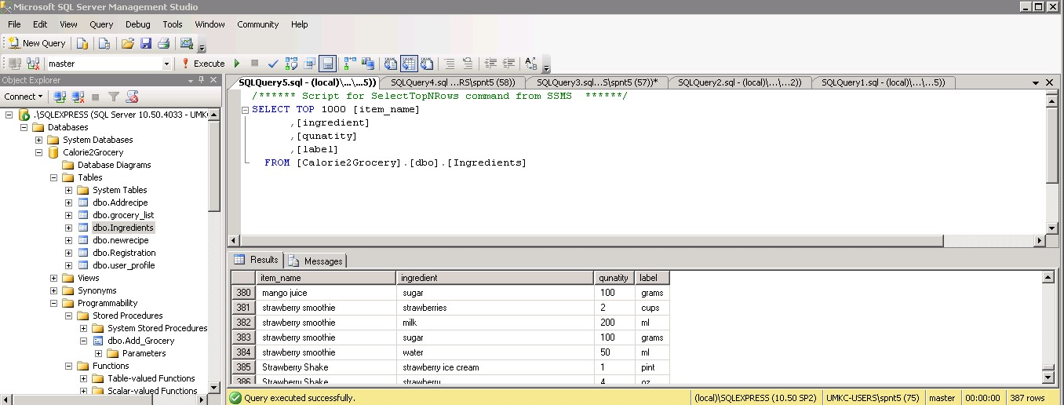

Screen Shot: 18 shows that the above created recipe has been added to the database successfully.

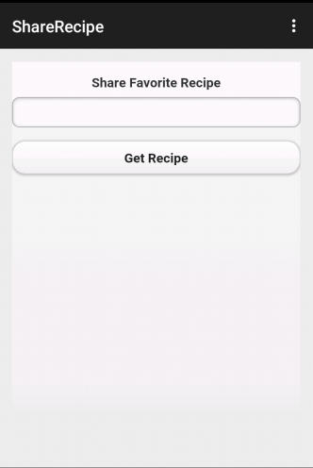

**Share Recipe in Facebook and Twitter:**

* The user can enter the recipe name and search from the database to get the recipe details.
* **Get Recipe:** Gives the list of recipes, that maches the keyword along with share options.

Screen Shot: 19 Share Recipe Page

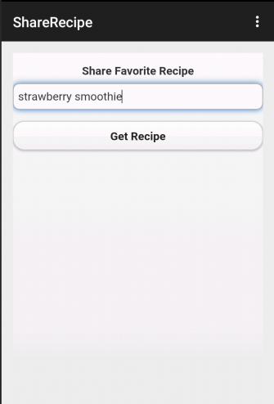

**Share Recipe Page**

* Screenshot shows searching for strawberry smoothie recipe that was previously created.

Screen Shot: 20 Share Recipe

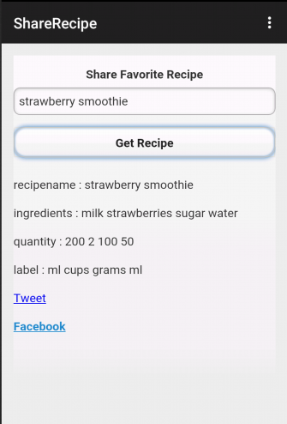

**Share Recipe Page**

* Screenshot shows displaying the details of the strawberry recipe.

Screen Shot: 21 Showing the recipe details

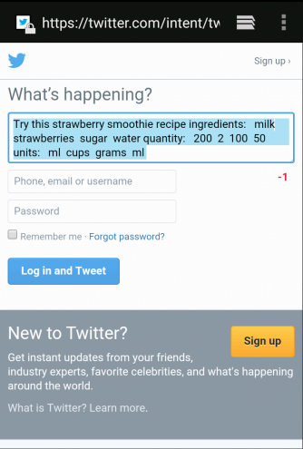

**Share Recipe using Twitter**

* On clicking the Tweet hyperlink, user can login to twitter and share the recipe.

Screenshot: 22

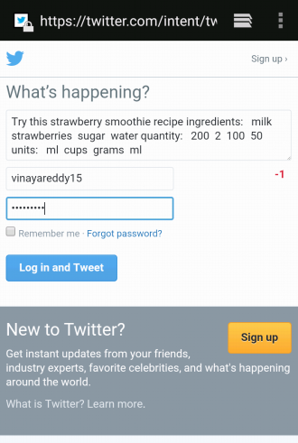

Screenshot : 23

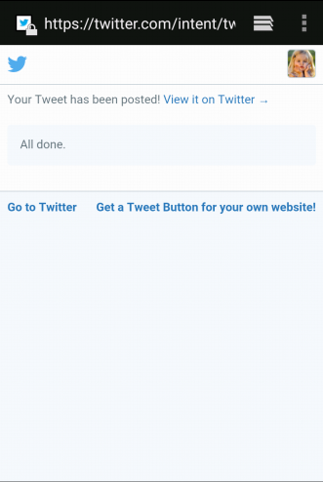

**Share Recipe using Twitter**

* Screenshot showing success message after posting the tweet.

Screenshot : 24

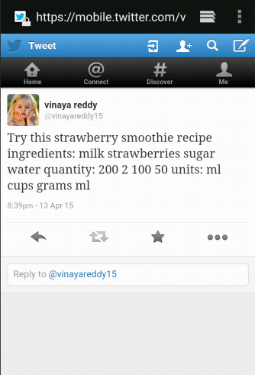

**Share Recipe using Twitter**

* Screen shot showing the post in twitter page.

Screenshot :25 Twitter post

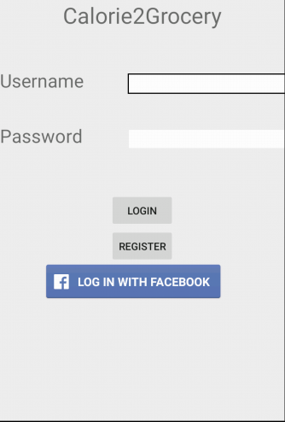

**Facebook Login**

* In Increment#1 , we had an issue with the facebook login. After login, the UI was not transitioning to our application.
* We have fixed that issue in increment#3.

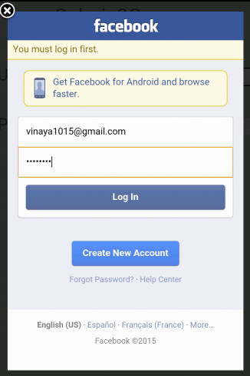

**Facebook Login**

* This screenshot shows entering the login details for Facebook.

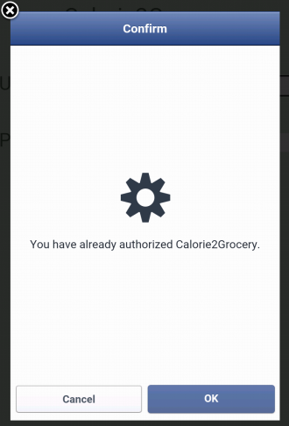

**Facebook Login**

* This screenshot shows that the user has authorized the Calorie2Grocery application to access basic info from facebook.



**Facebook Login**

* This screenshot shows the successful transition of UI from Facebook login to our application.

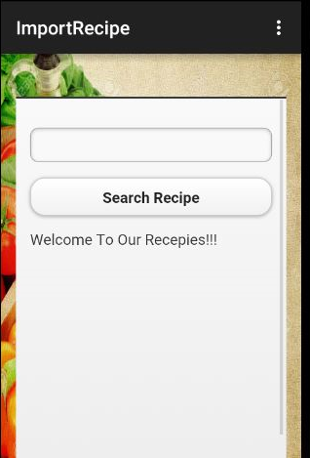

**Search Recipe**

* The user gets the search recipe page when he clicks the search recipe button in home page.
* The user can search any recipe by giving the keywords in the search bar.

**Technical Details:**

* The client side logic is implemented using web technologies JavaScript, Jquery & Ajax
* Used bootstrap style sheets.

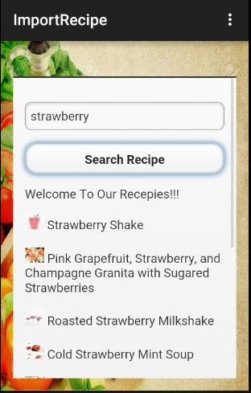

**Search Recipe**

* User enters strawberry as a search key to get various recipe on strawberry
* User clicks the search recipe button

**Technical Details:**

* We are using the recipe & diet api to fetch the recipe information based on keyword search

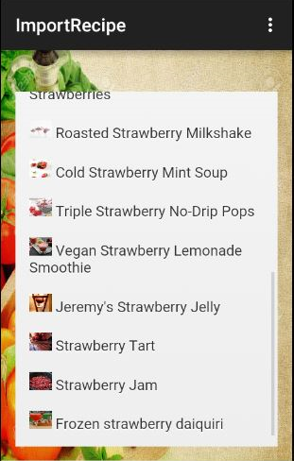

* List of the recipes of strawberry

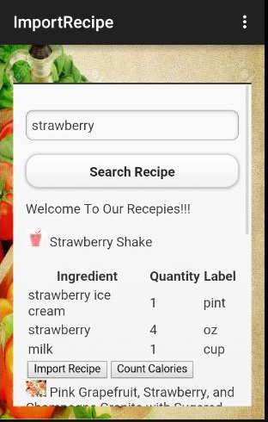

**Search Recipe**

* If user wants to view the ingredients required for preparing a recipe, user clicks on recipe name
* System displays the ingredient list for the recipe.
* If the user wants to import the recipe, user clicks on “Import Recipe” button
* System loads the recipe & ingredients details to the database.

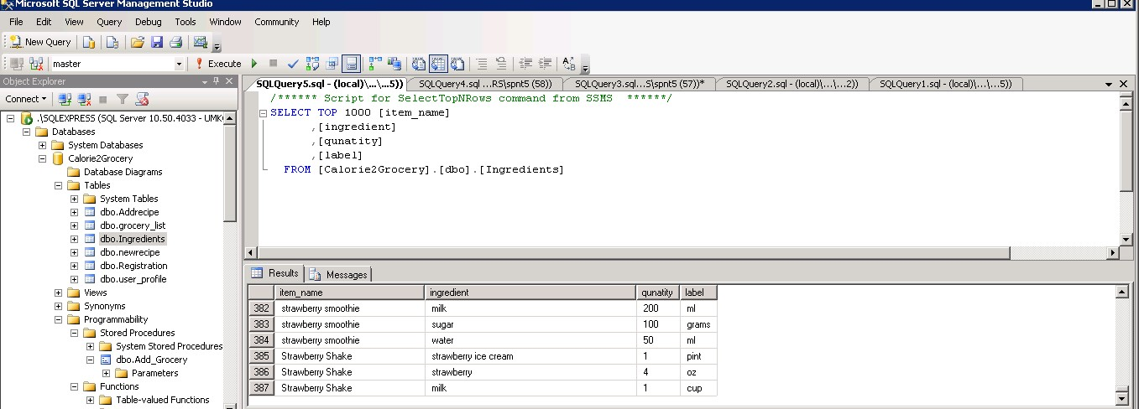

Imported the Strawberry Shake into the Ingredients Table

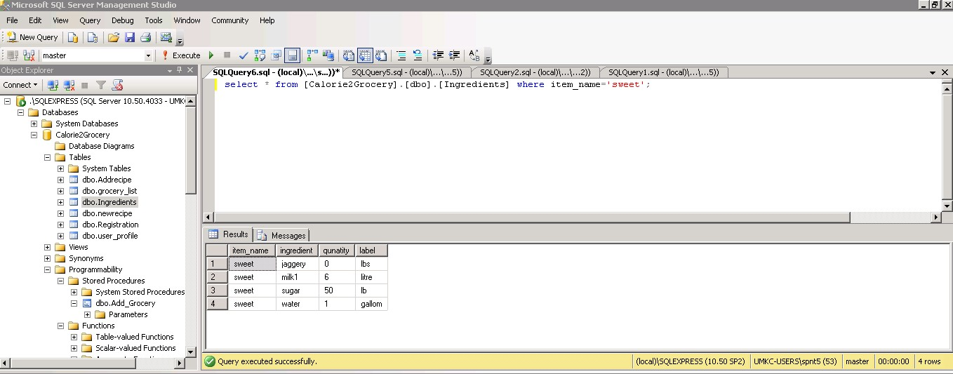

Screenshot the Ingredients list before the update the sweet Recipe

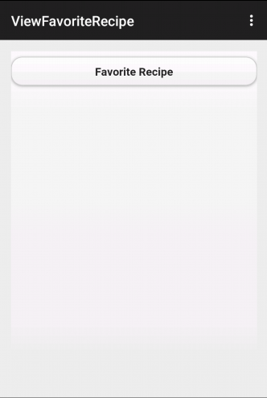

* User Clicks the Favorite Recipe to get the Favorite Recipes stored in Ingredients Database.
* **Technical Details:** The client side logic is implemented using web technologies JavaScript, Jquery & Ajax
* Used bootstrap style sheets.

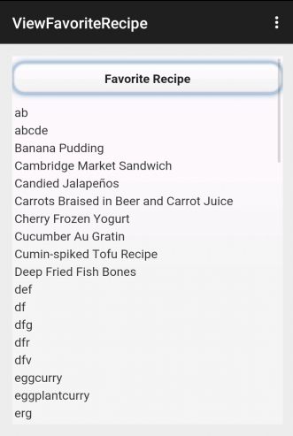

* User gets the favorite Recipe which he stored by clicking import Recipe Button.
* **Technical Details:** Created a webservice for displaying the list of recipes by using C#.

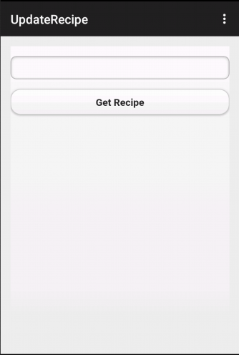

* User can search for the recipe using the Get Recipe button.
* **Technical Details:** The client side logic is implemented using web technologies JavaScript, Jquery & Ajax
* Used bootstrap style sheets.

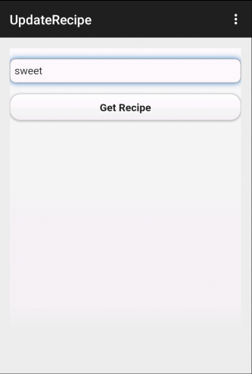

* User search for the sweet recipe

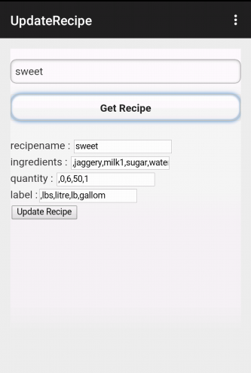

* User gets the sweet recipe ingredients list, quantity ,label.
* User can add , delete, update the ingredients or quantity or label according to her desire
* **Technical Details:** Created a webservice using C# and update the ingredients list, quantity and label.

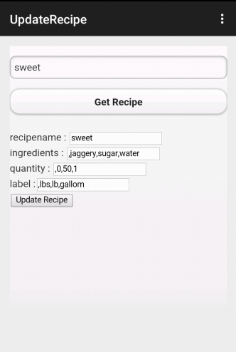

* Delete the milk ingredient and quantity and label for the sweet Recipe.
* User clicks the update Recipe and successfully updates the recipe of sweet.

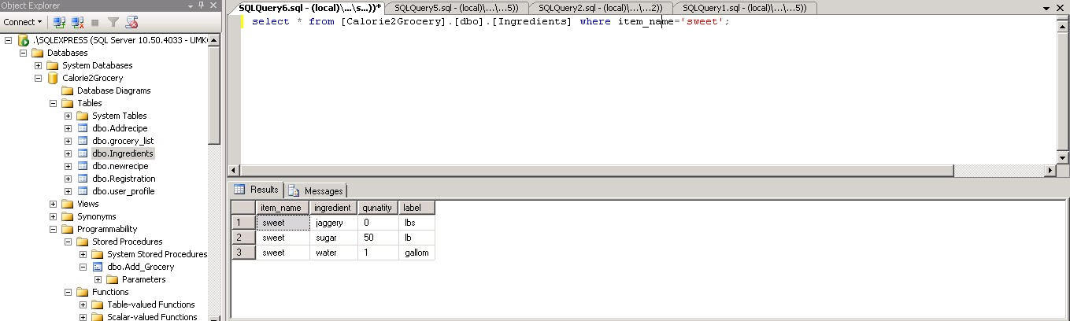

Ingredients table for sweet Recipe after updating the ingredients list, quantity ,label.

1. **Design Of Unit Test Cases**

**UI Testing:**

The following test cases has been written for UI testing and the actual output is validated with expected output. All of the below test cases which have been written obtained positive results.

|  |  |  |  |
| --- | --- | --- | --- |
| **Page** | **Button** | **Expected** | **Actual** |
| View Grocery list | view | Should display grocery list | Displaying grocery list |
|  | edit | Should modify the ingredients, quantity and label | Able to modify the ingredients, quantity and label |
|  | delete | Should delete the grocery items | Deleted the grocery items |
| Calorie count | Browse for a recipe | Should display list of the different recipes | Displays the list of different recipes |
|  | Select a particular recipe | Should display the ingredients list for the selected recipe | Displays the ingredients list for the selected recipe |
|  | Calorie count | Should display individual and total calorie count of ingredients | Displaying individual and total calorie count of ingredients |
| Get recipe and modify | Import recipe | The list of recipes should be added to the database | The list of recipes are added to the database |
|  | View recipe | Should display the recipe list | Displays the recipe list |
|  | Update recipe | Should allow us to update the ingredient, quantity , label of recipe | Allowing us to update the ingredient, quantity , label of recipe |
| Create new recipe | Create recipe | Add new recipe ingredients, quantity, label to database | Adding new recipe ingredients, quantity, label to database |
| Get recipe and share | Get recipe | should get imported and created recipes | Able to get imported and created recipes |
|  | Share recipe | Should share recipes to twitter and facebook | Able to share recipes to twitter and facebook |
| Notification | Send Notifications | Send Notifications to expiry dates | Sending Notifications to expiry dates |

**Data Validation:**

We have implemented N-Unit test cases to validate the data for all the newly created web services. We have used Assert methods to compare the actual output with the expected output.

**Screenshot of N-Unit validation:** This is used to validate the data for update grocery item method in the rest service.

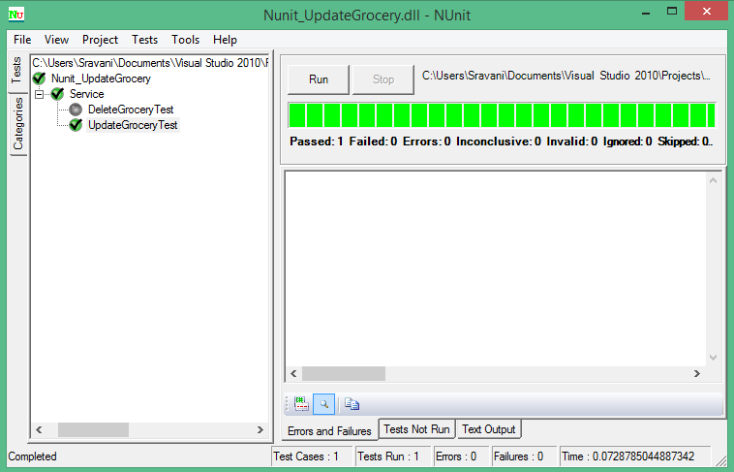

**Screenshot for N-Unit validation of delete groceries API:**

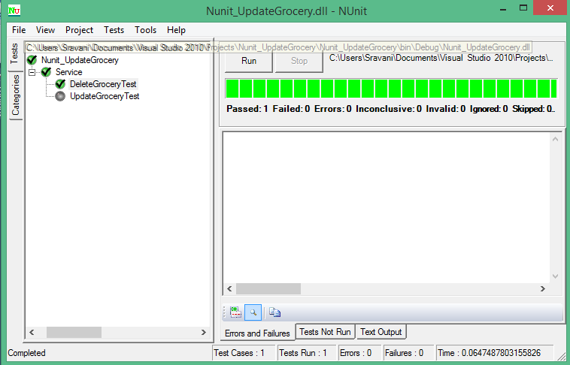

**Screenshot for N-Unit validation of Import groceries API:**

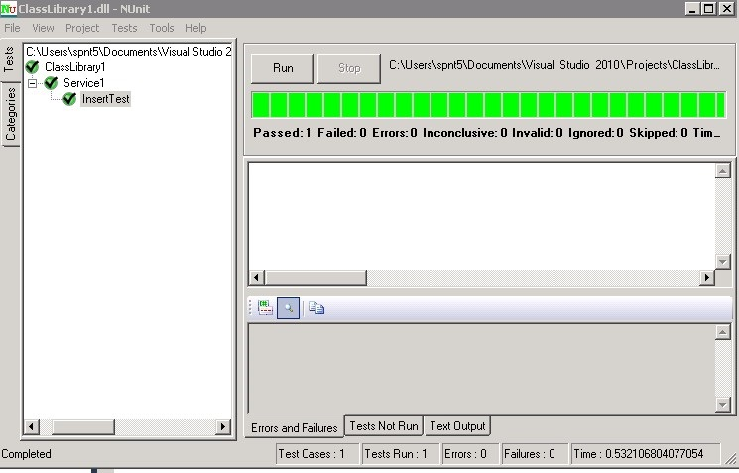

**Screenshot for N-Unit validation of Update groceries API:**

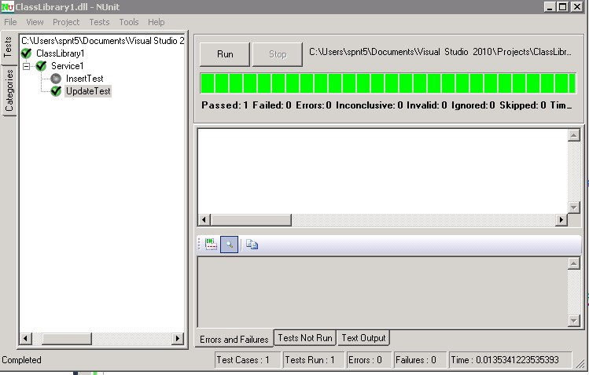

**Performance Testing:**

The following are the tools we used for performance testing:

* YSlow analyzer
* Firebug

1. **YSlow Analyzer:** This is a free, open source testing tool that analyzes web pages and suggests ways to improve their performance. The below screenshots shows the performance analysis of the web pages that are created in our app. This analysis is done using YSlow analyzer(Google chrome extension).

**Testing for a web page that generates notification about expiry dates**

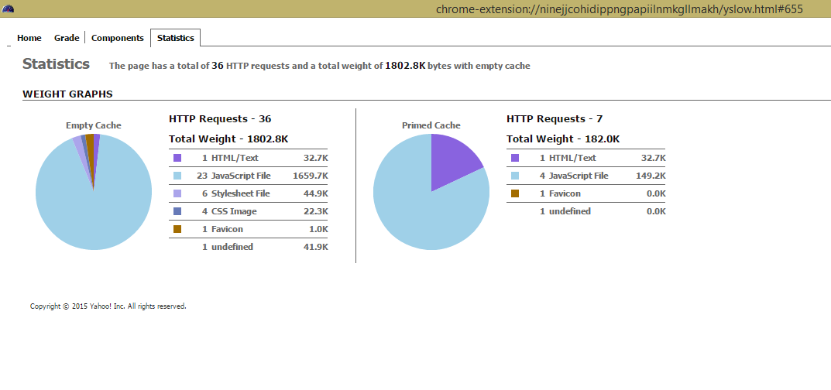

Screen Shot: 1

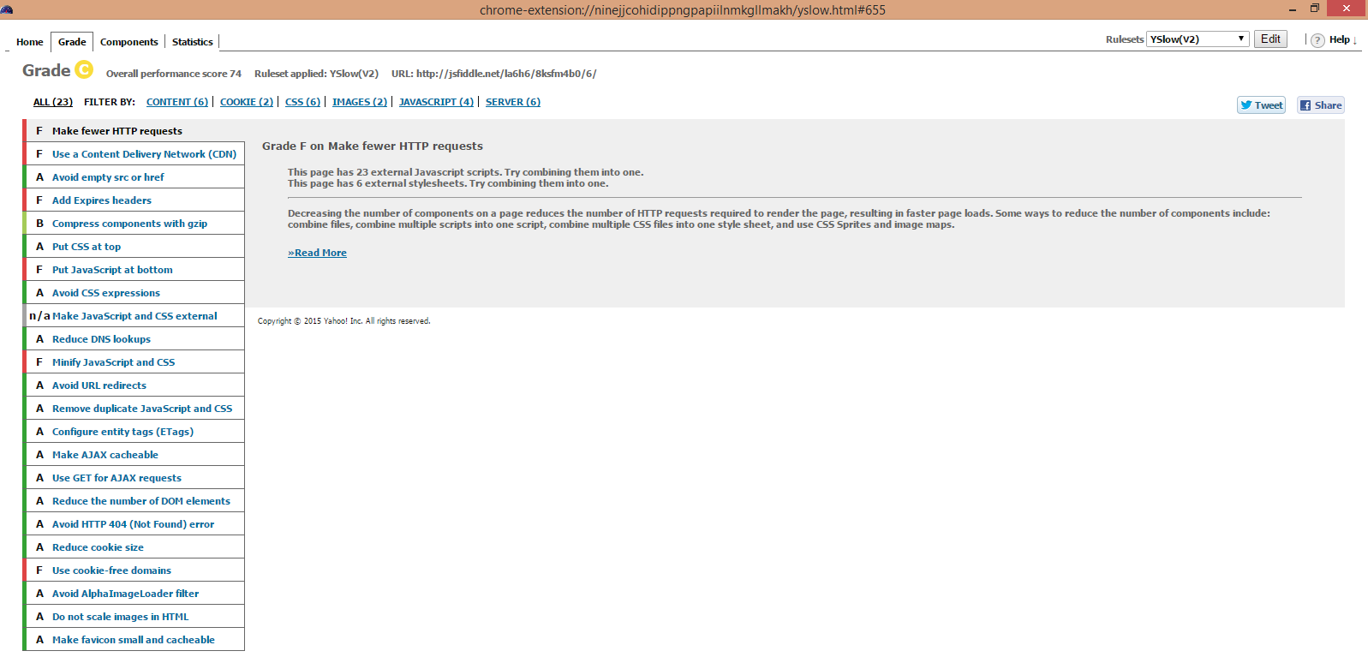

Screen Shot: 2

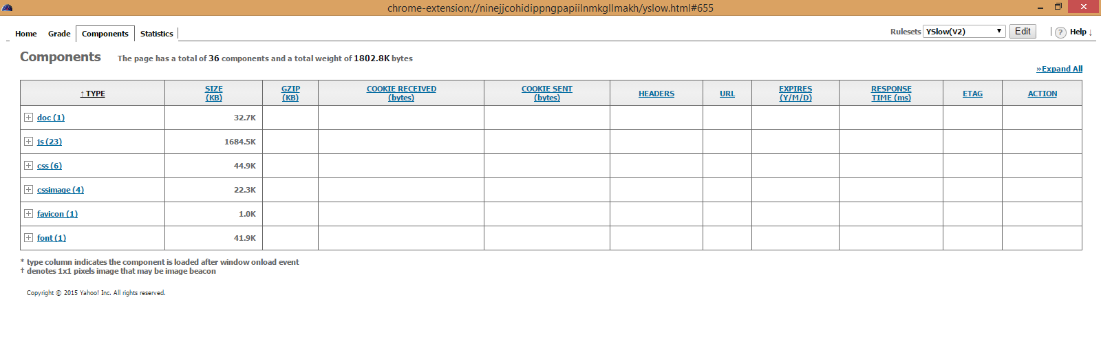

Screen Shot: 3

**Testing for a web page that searches a recipe from the database and share it on facebook and twitter**

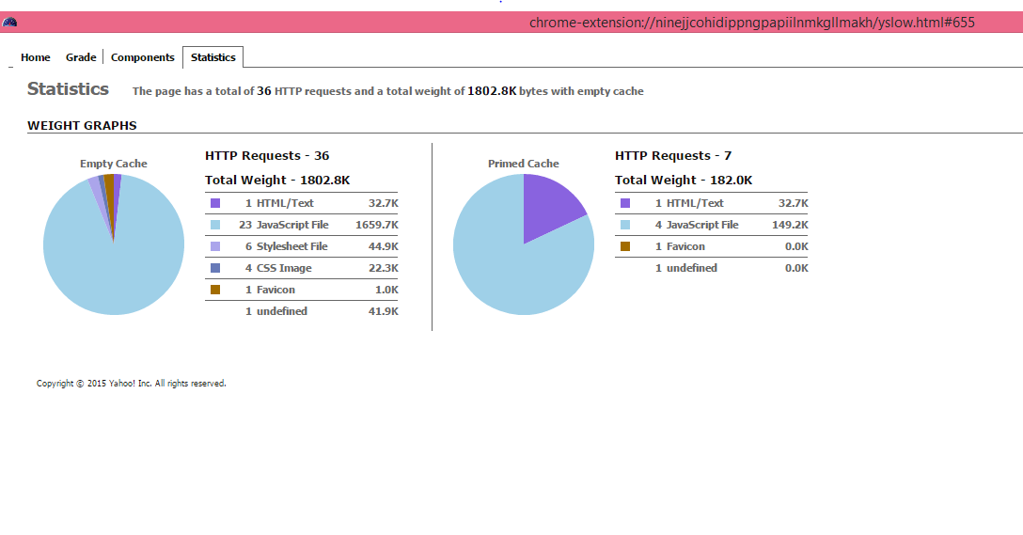

Screen Shot: 1

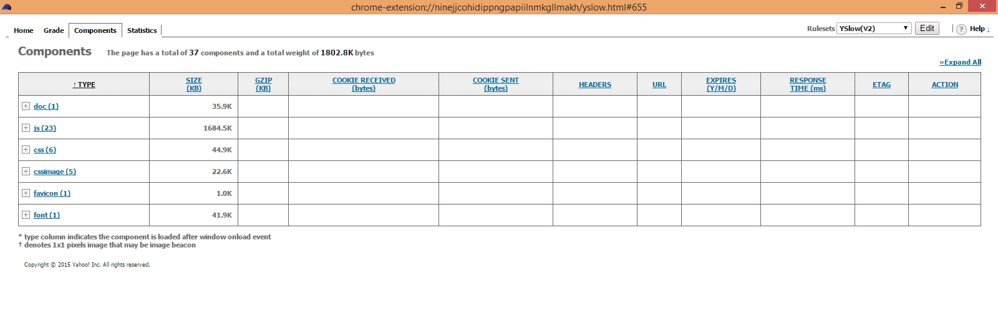

Screen Shot: 2

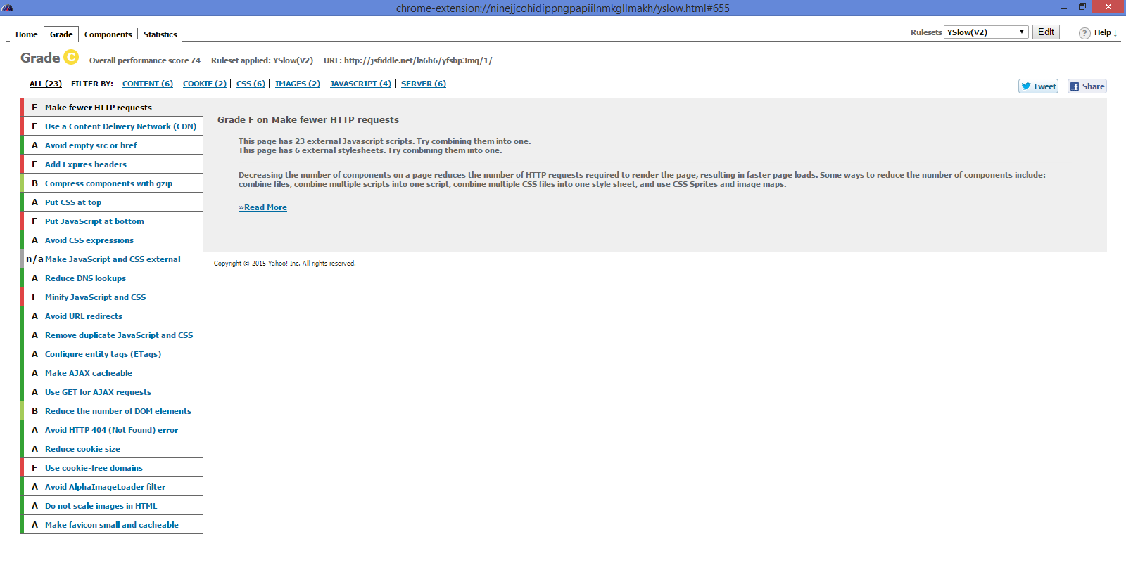

Screen Shot: 3

**Testing for a web page for Creating a recipe**

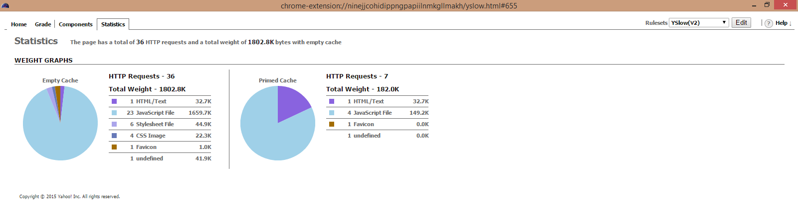

Screen Shot: 1

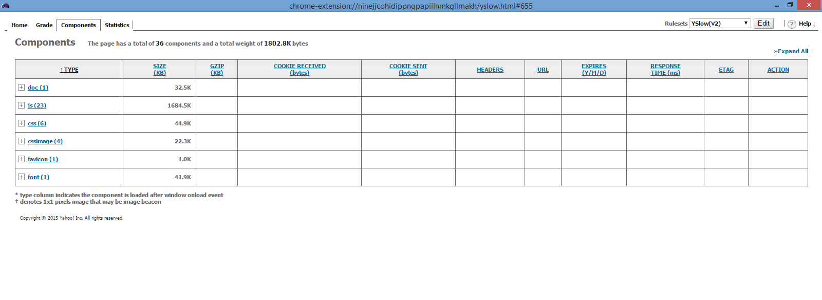

Screen Shot: 2

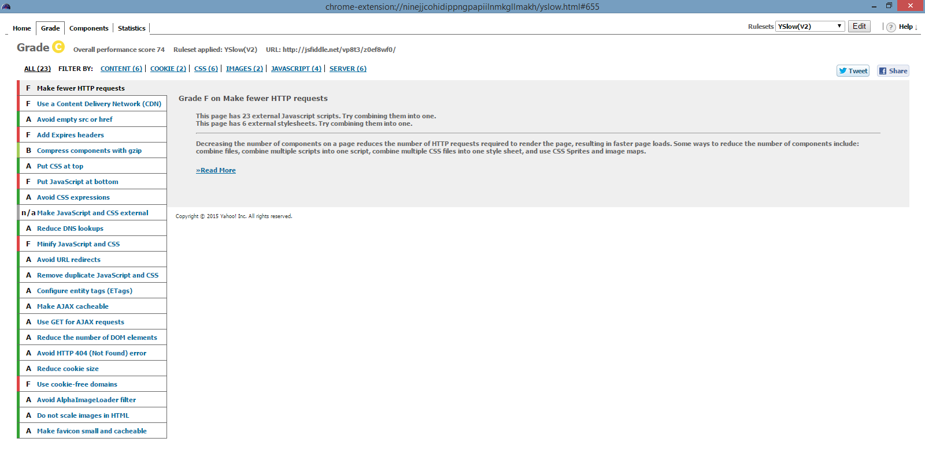

Screen Shot: 3

**Web Page for displaying a recipe long with calorie count**

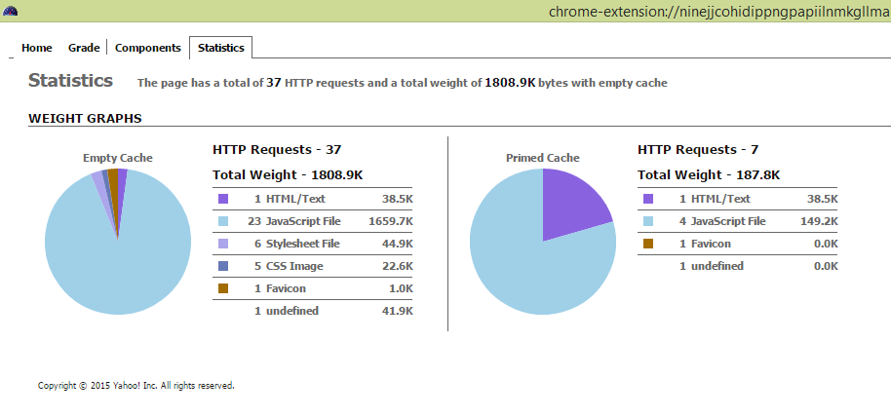

Screen Shot: 1

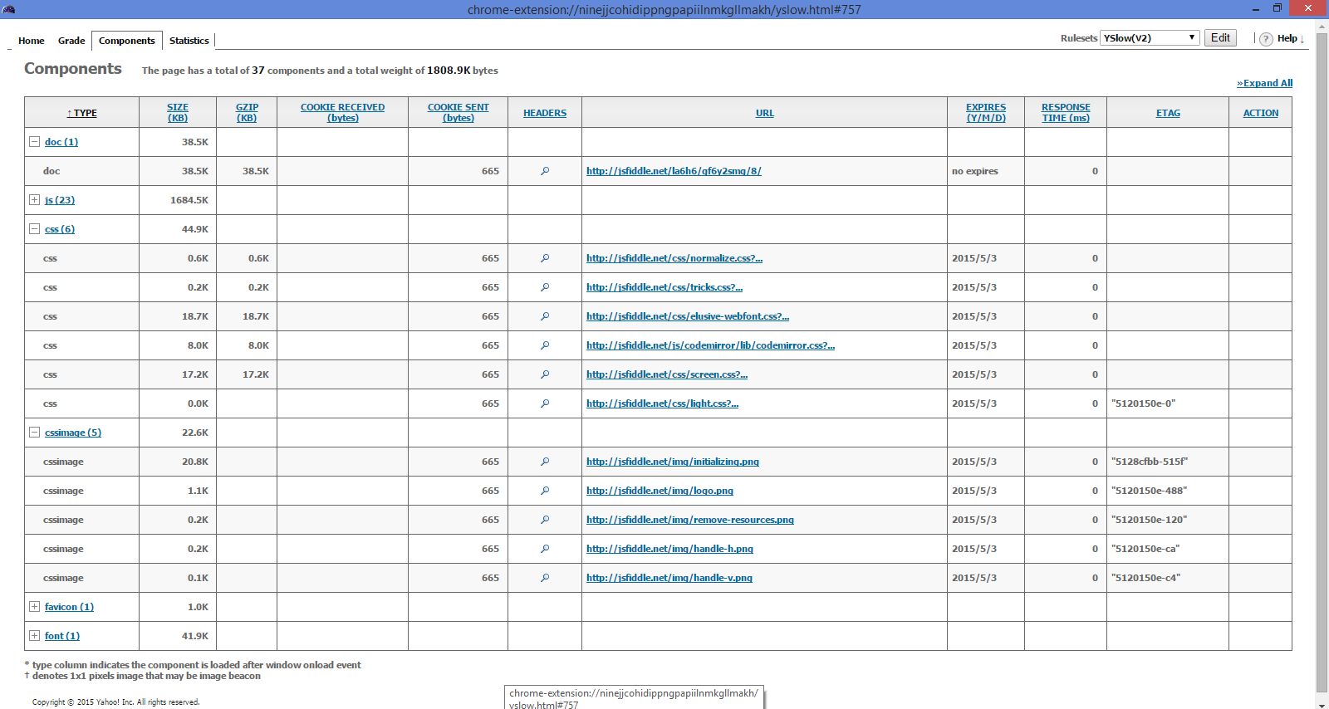

Screen Shot: 2

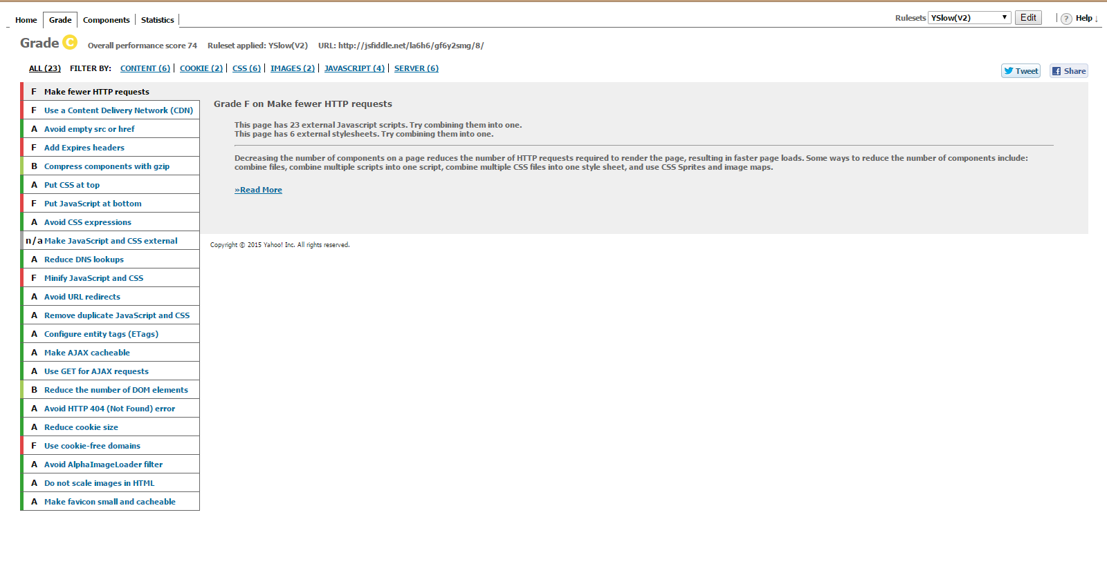

Screen Shot: 3

**Testing a web page that edits/removes the grocery item**

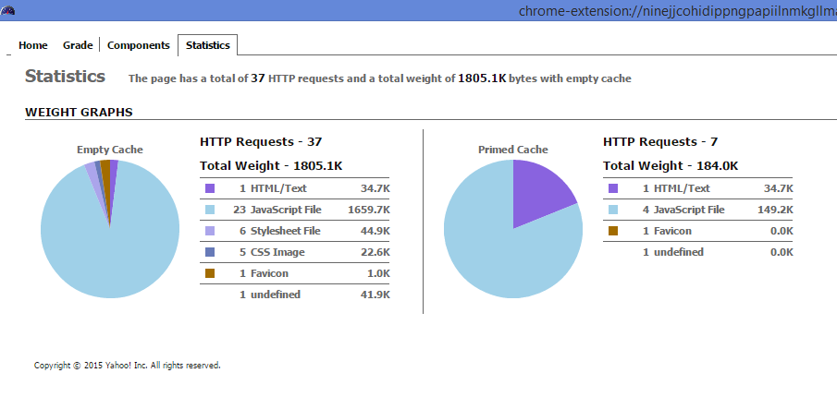

Screen Shot: 1

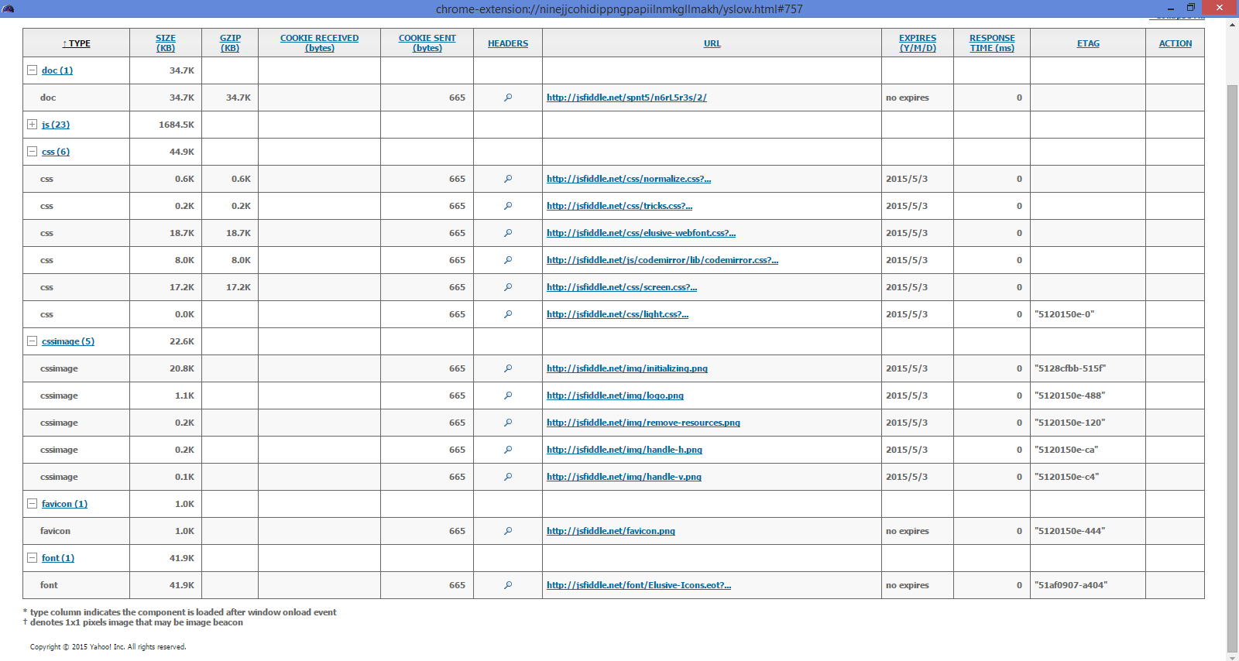

Screen Shot: 14

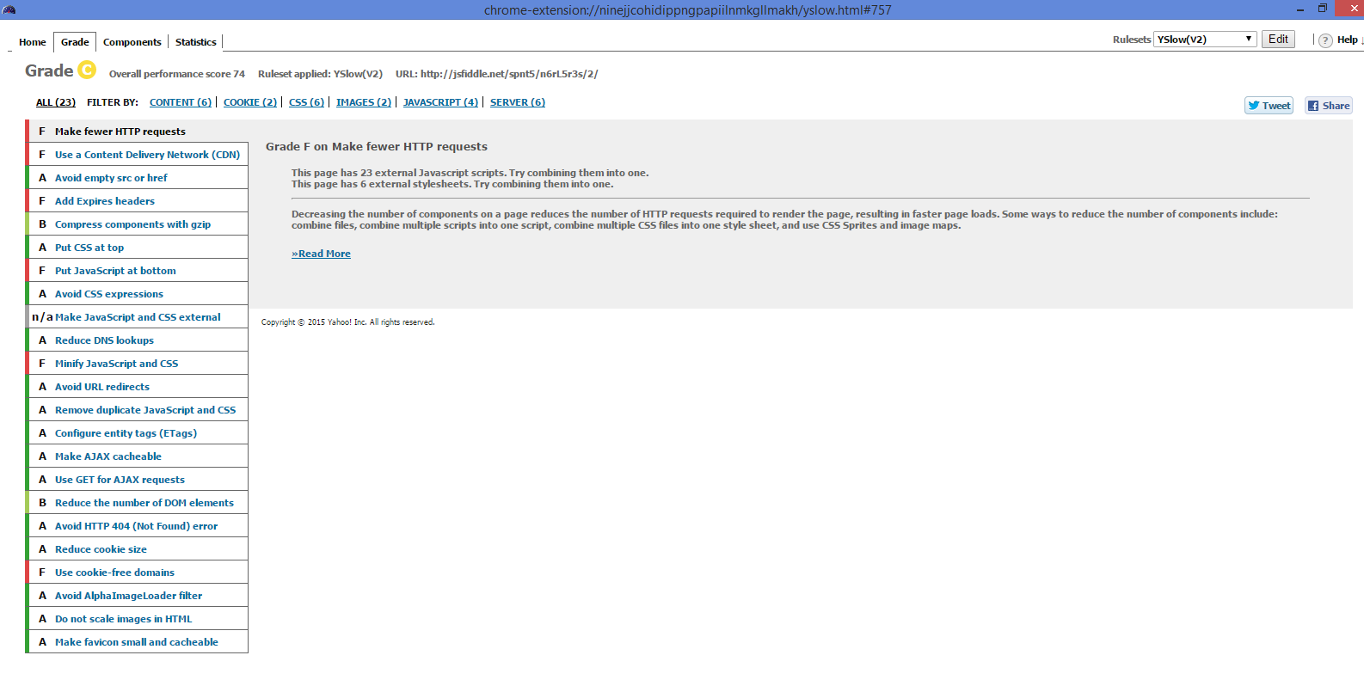

Screen Shot: 15

**Testing a web page for updating a recipe**

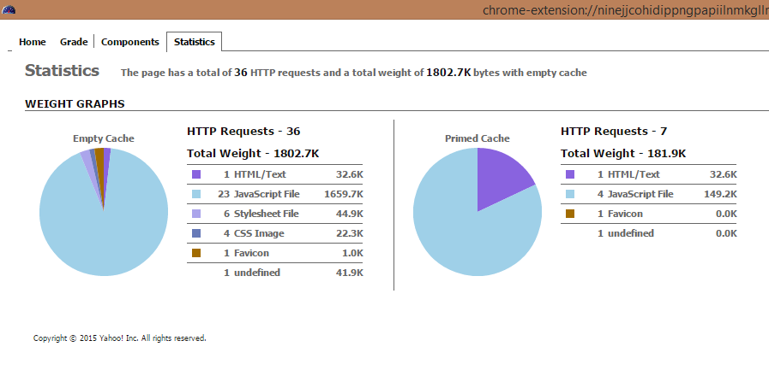

Screen Shot: 1

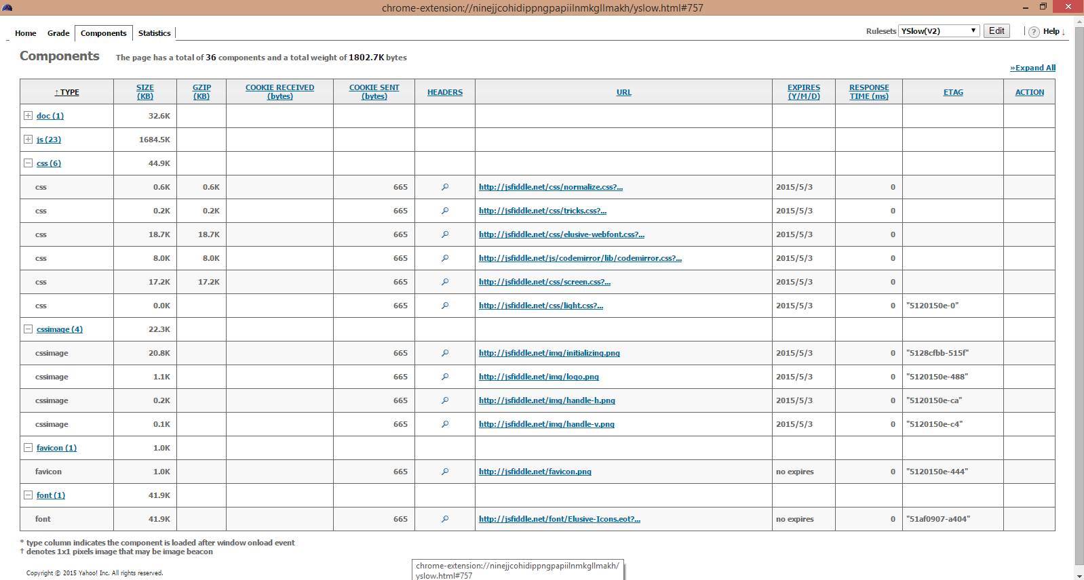

Screen Shot: 2

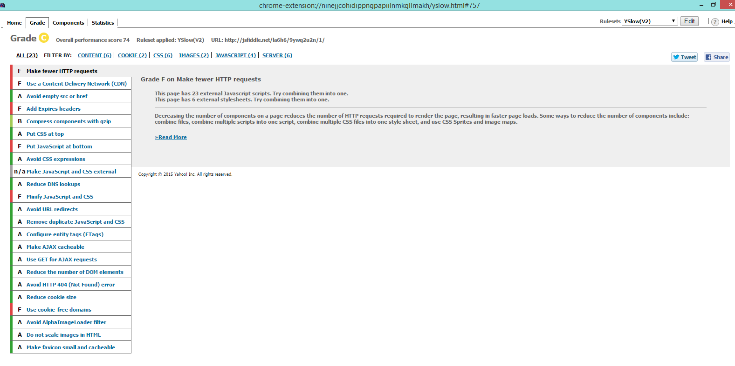

Screen Shot: 3

**Testing a web page for getting the favorite recipe**

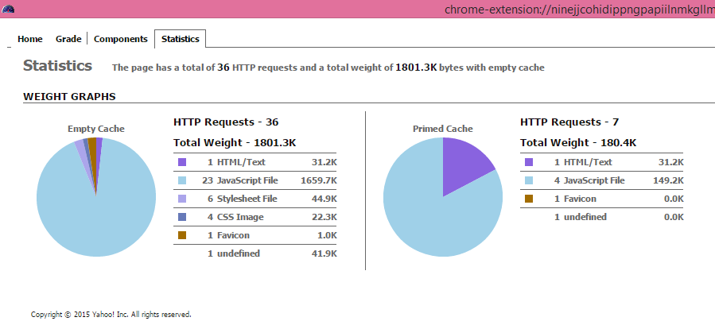

Screen Shot: 1

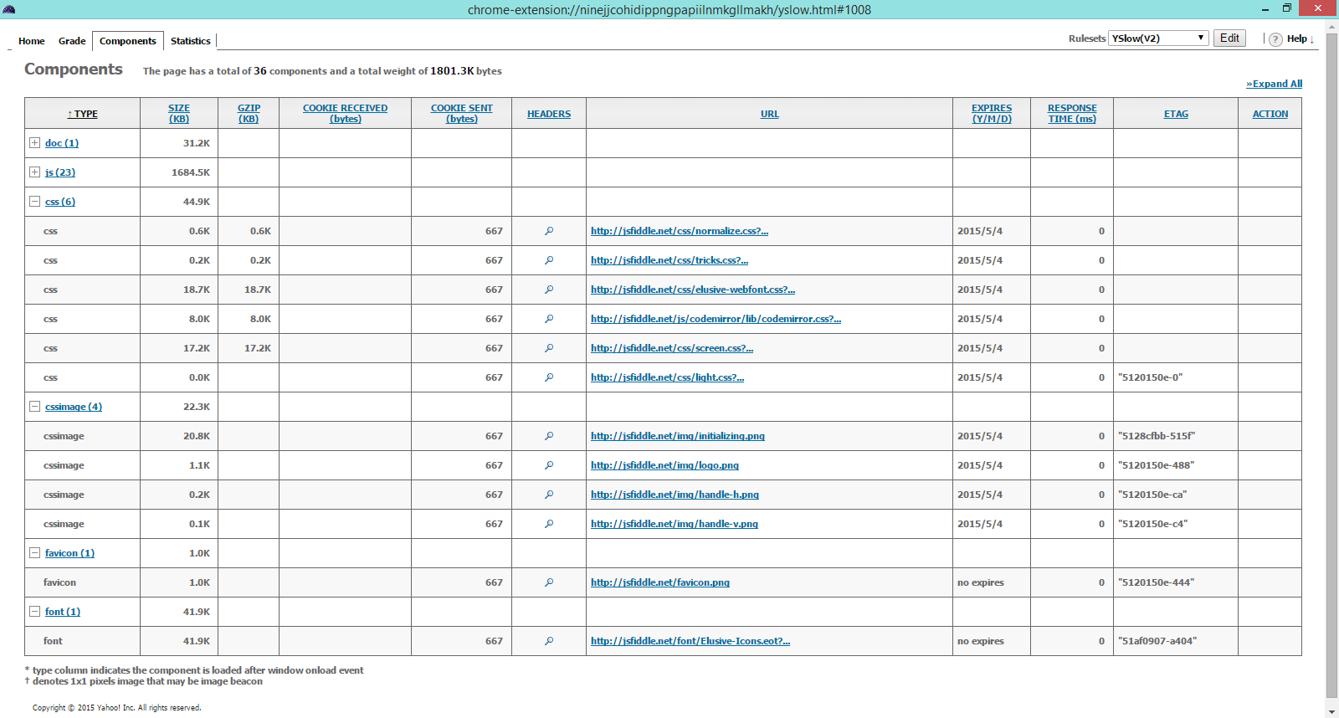

Screen Shot: 2

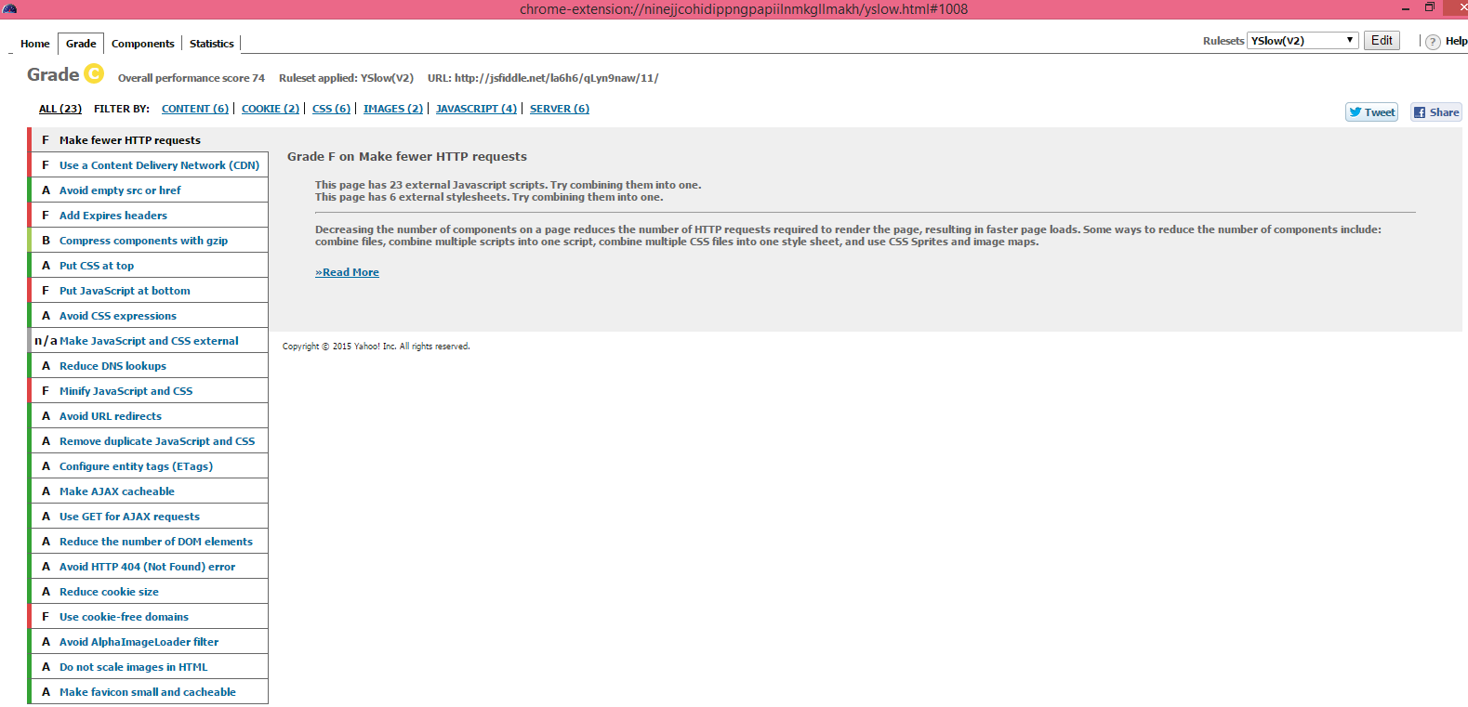

Screen Shot: 3

**Testing a web page for import and updating a recipe**

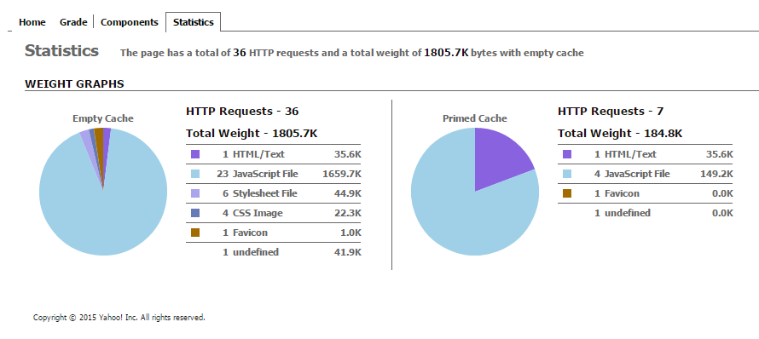

Screen Shot: 1

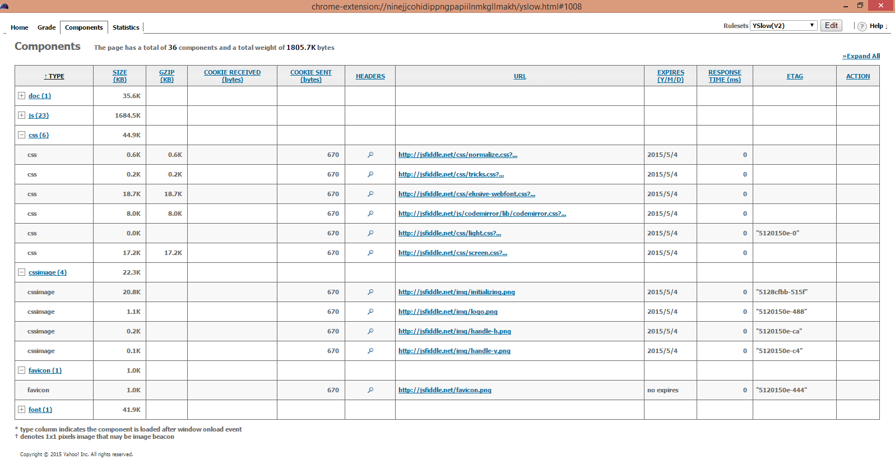

Screen Shot: 2

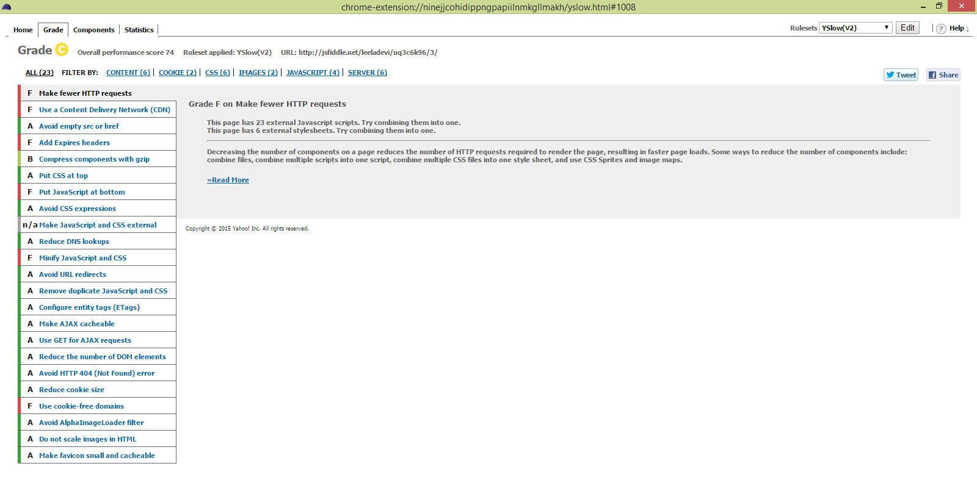

Screen Shot: 3

**Fire Bug tool:**

We used the fire bug tool to do the performance testing for html pages we used. The firebug tool will automatically show us if there are any errors in the JavaScript, CSS or HTML code. It also notify us if there are any errors in request URL’s or XHR requests. We have done this testing on all of the HTML pages we created in this increment. Mostly there are no errors detected while we performed this testing.

1. **Createrecipe.html**

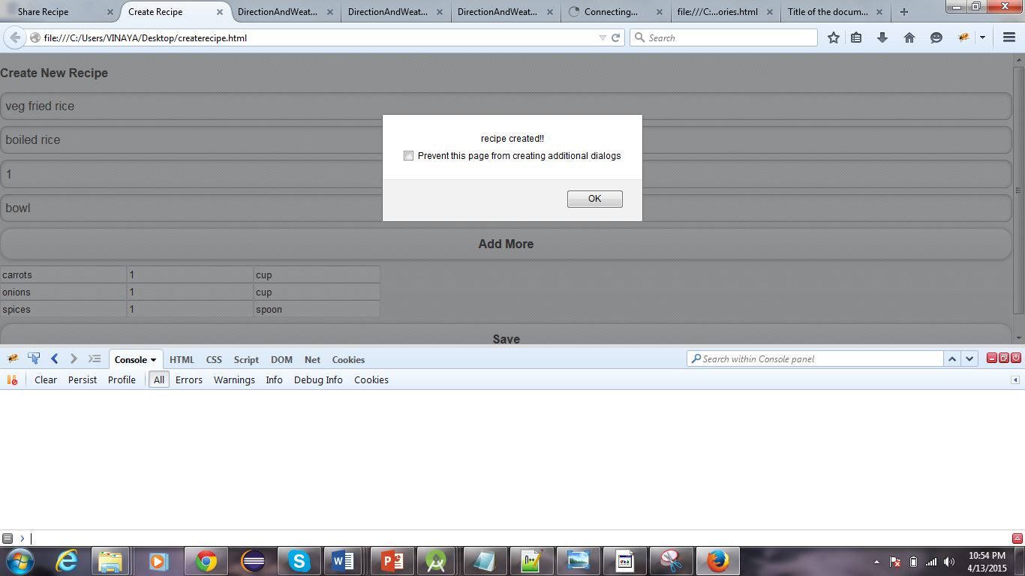

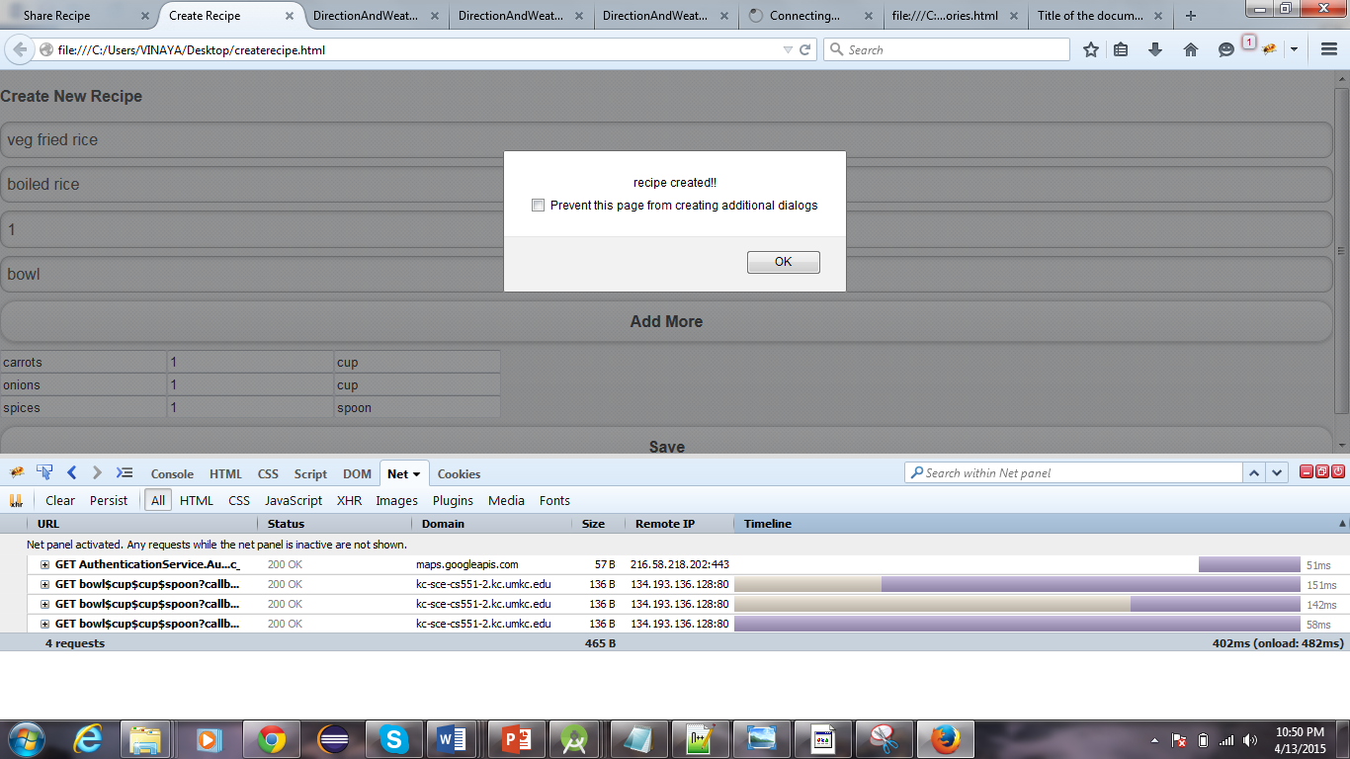

1. **Share Recipe.html**

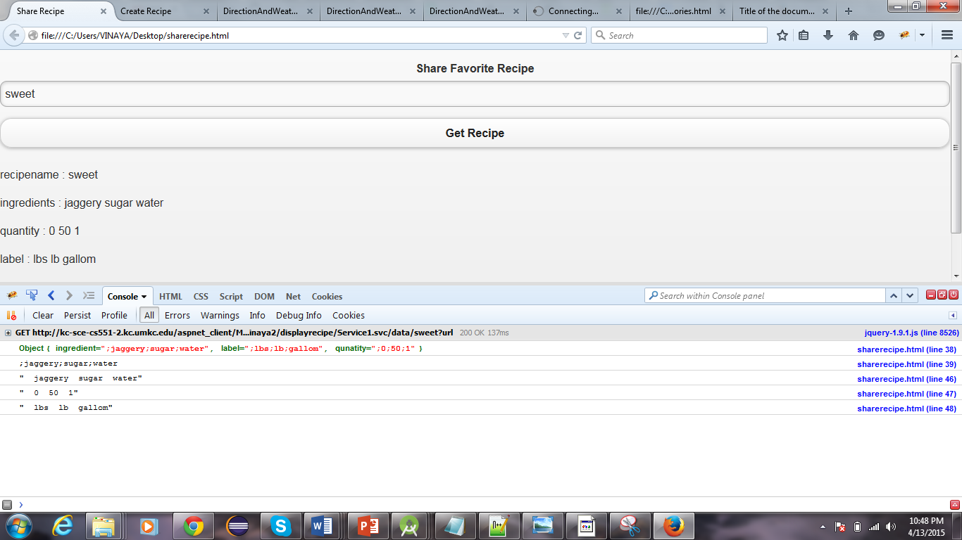

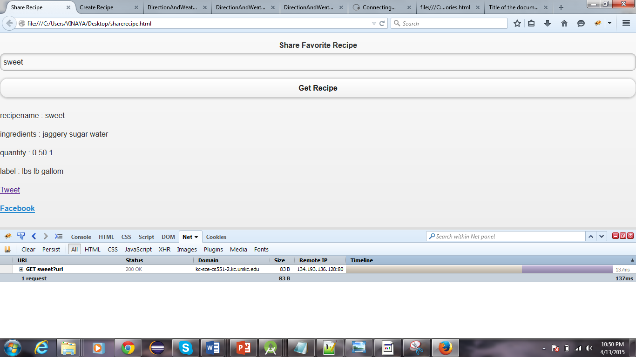

1. **viewRecipe.html**

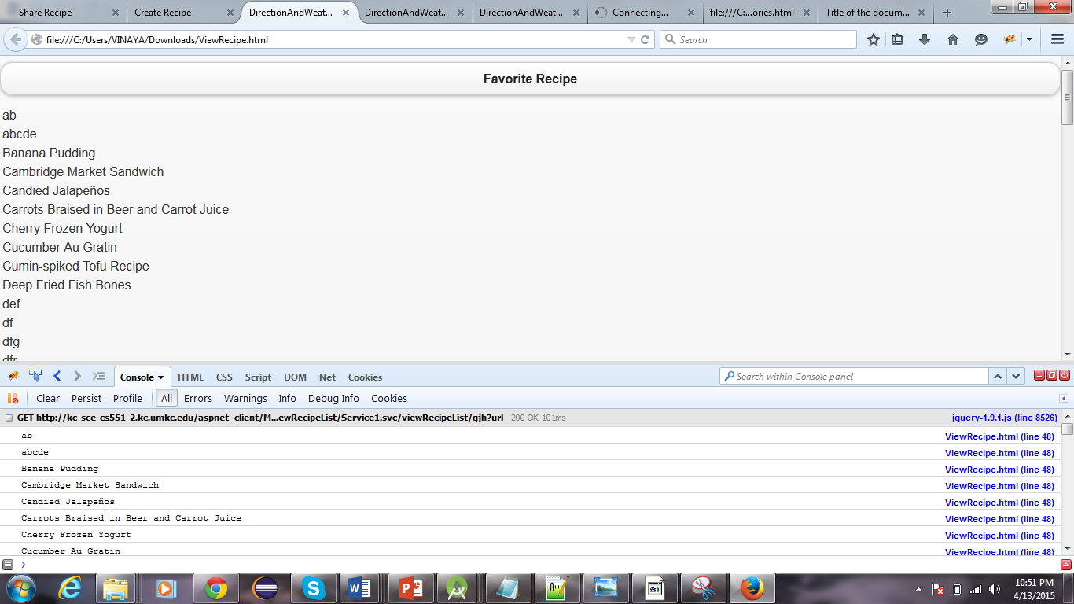

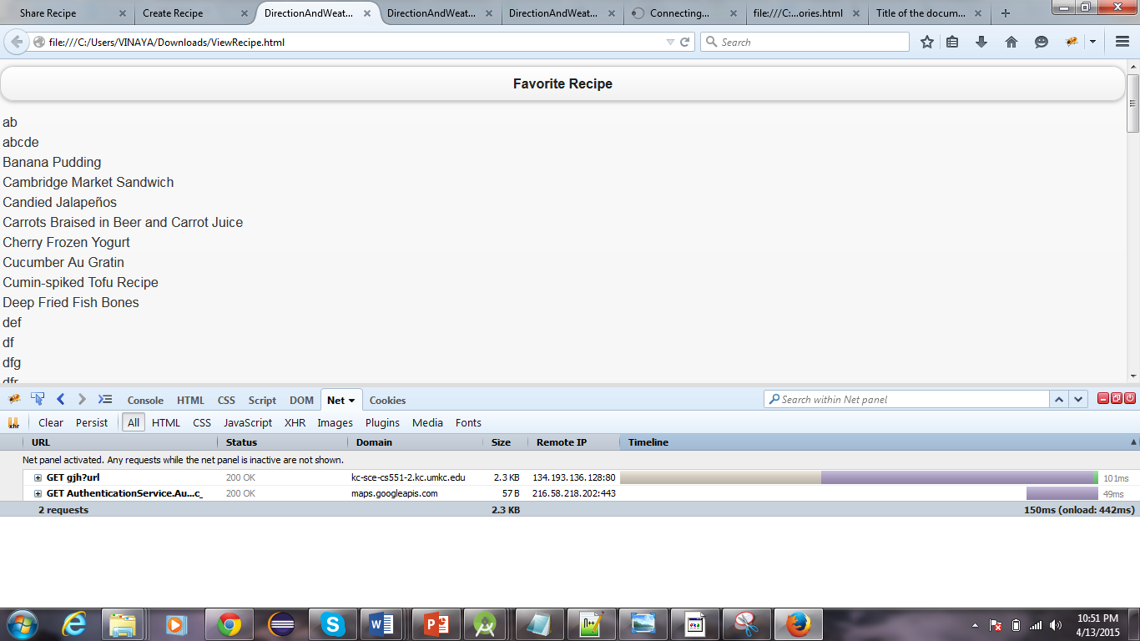

1. **Updaterecipe.html**

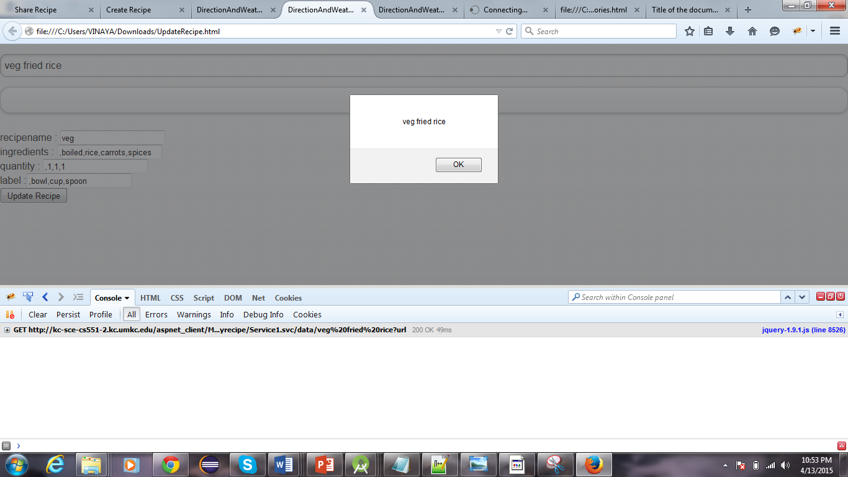

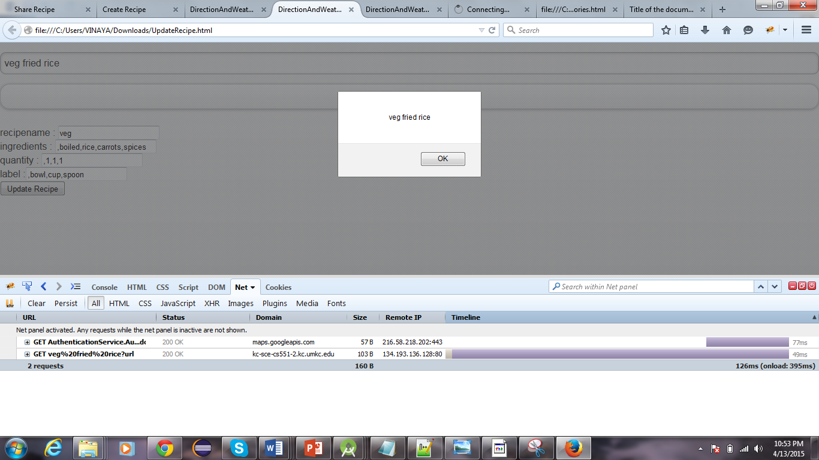

1. **Import Recipe.html**

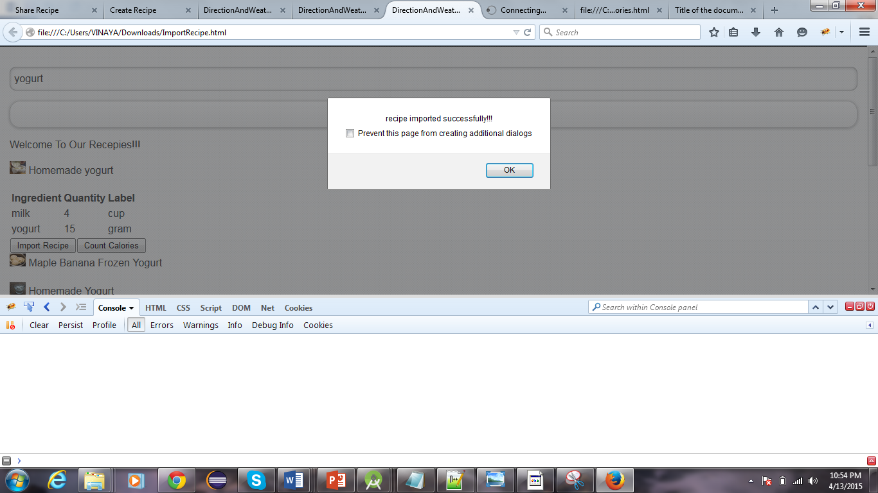

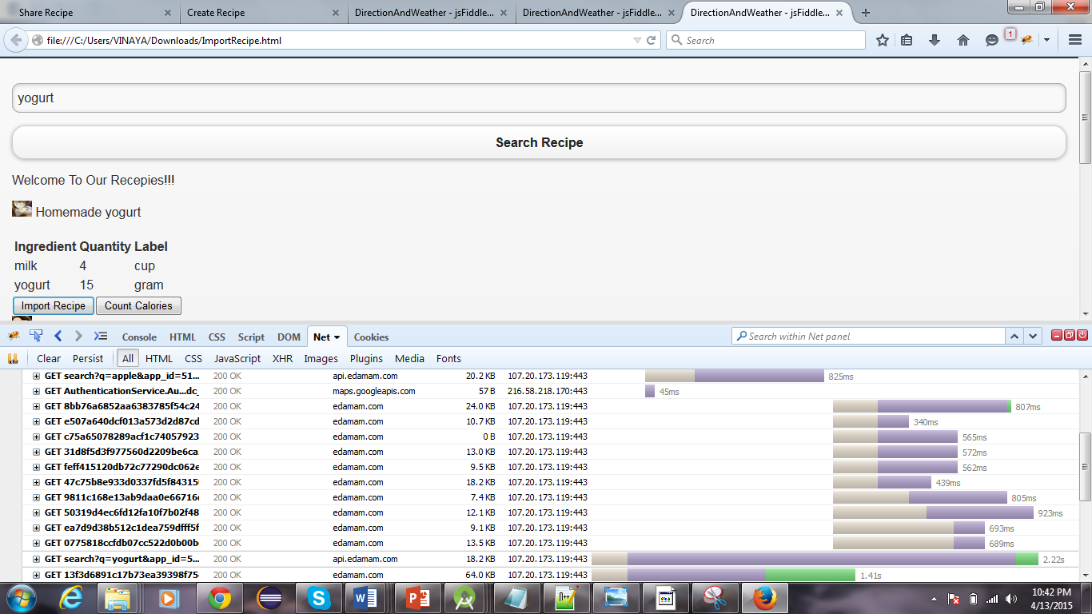

1. **Calorie.html**

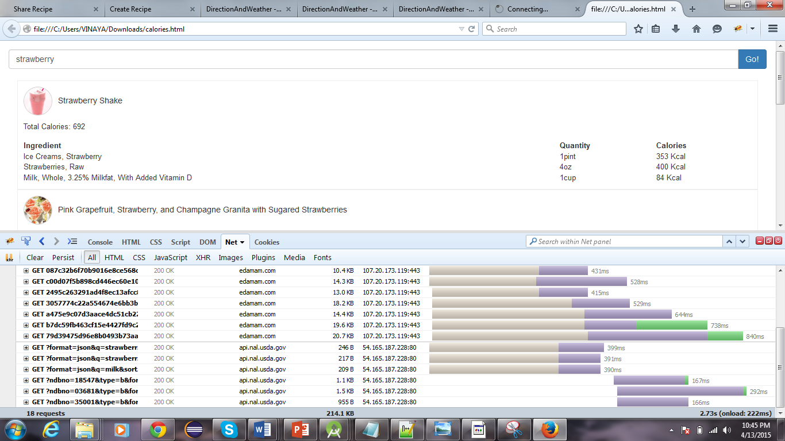

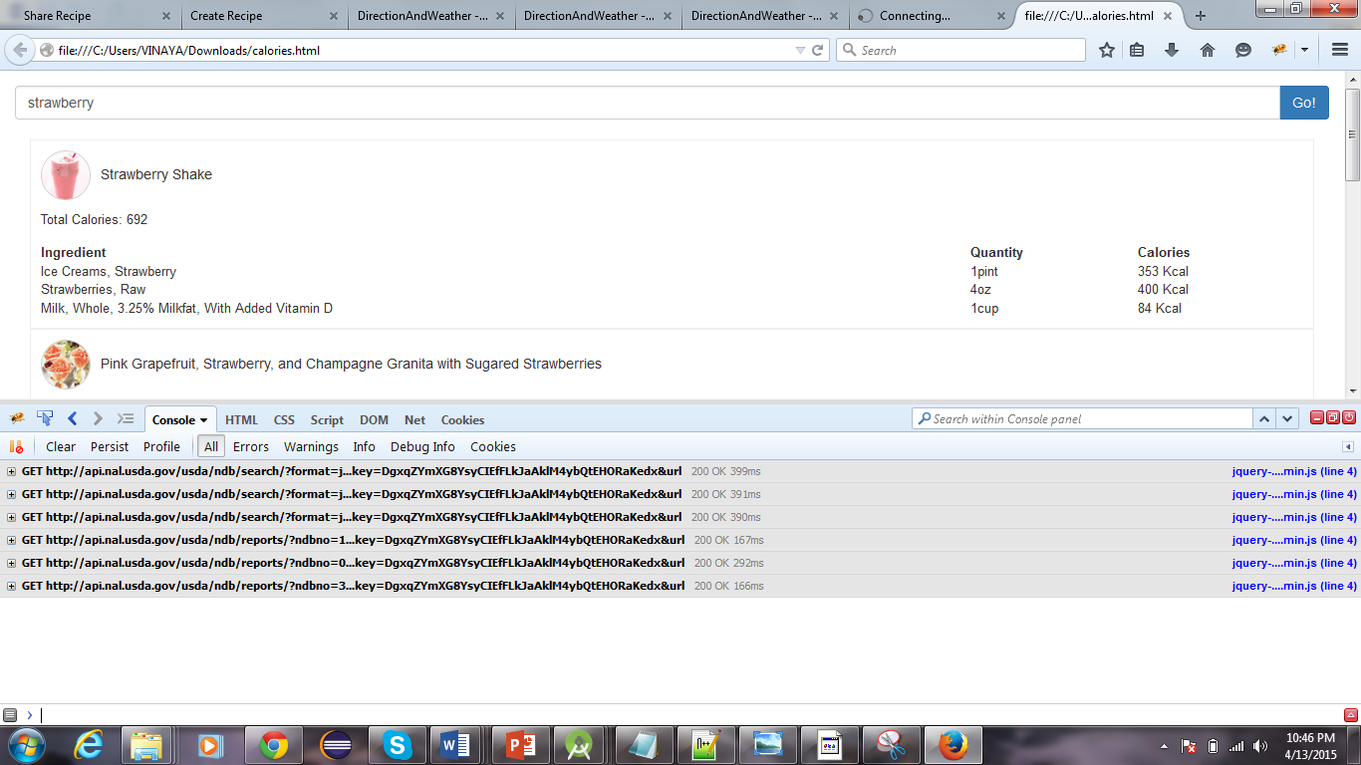

1. **Notification.html**

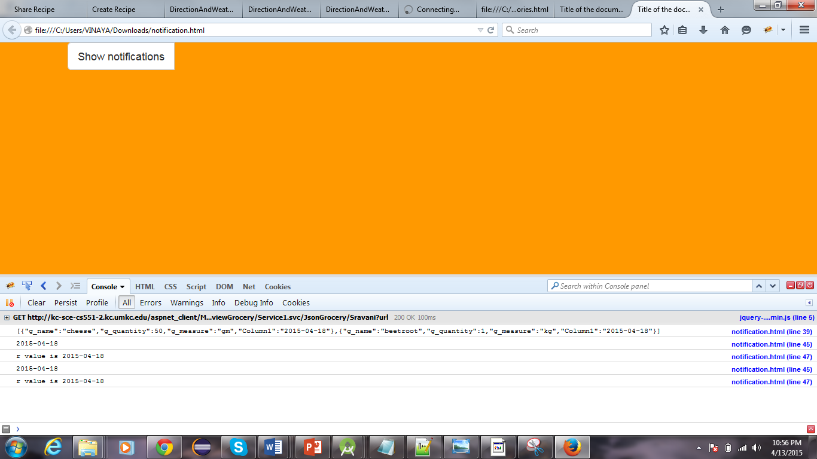

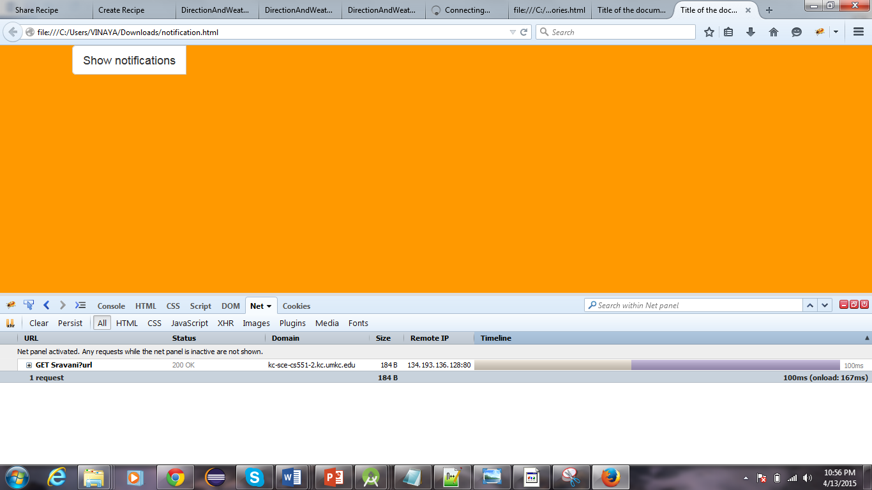

1. **viewGrocery.html**

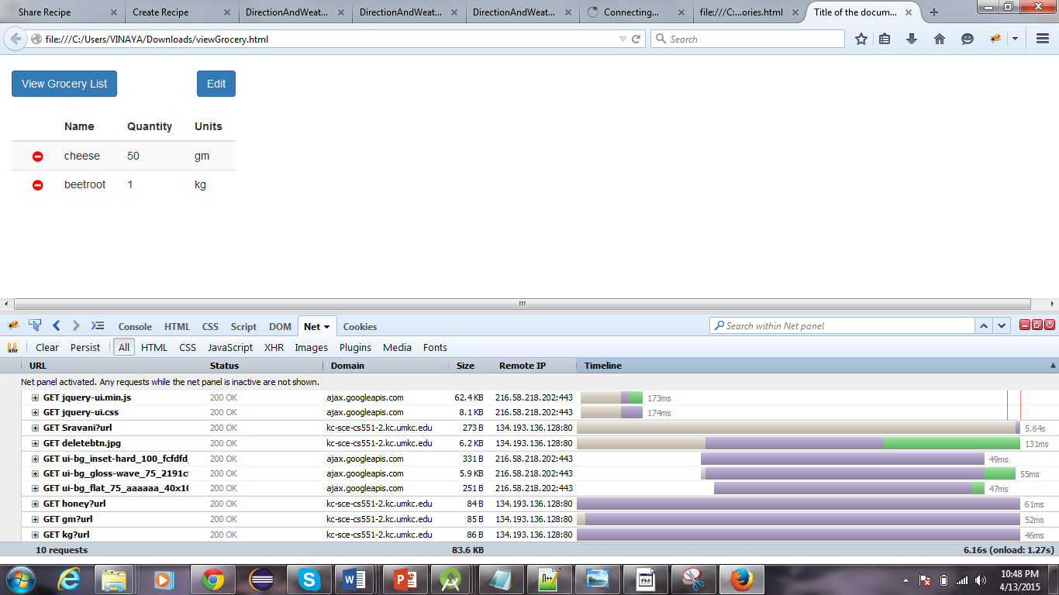

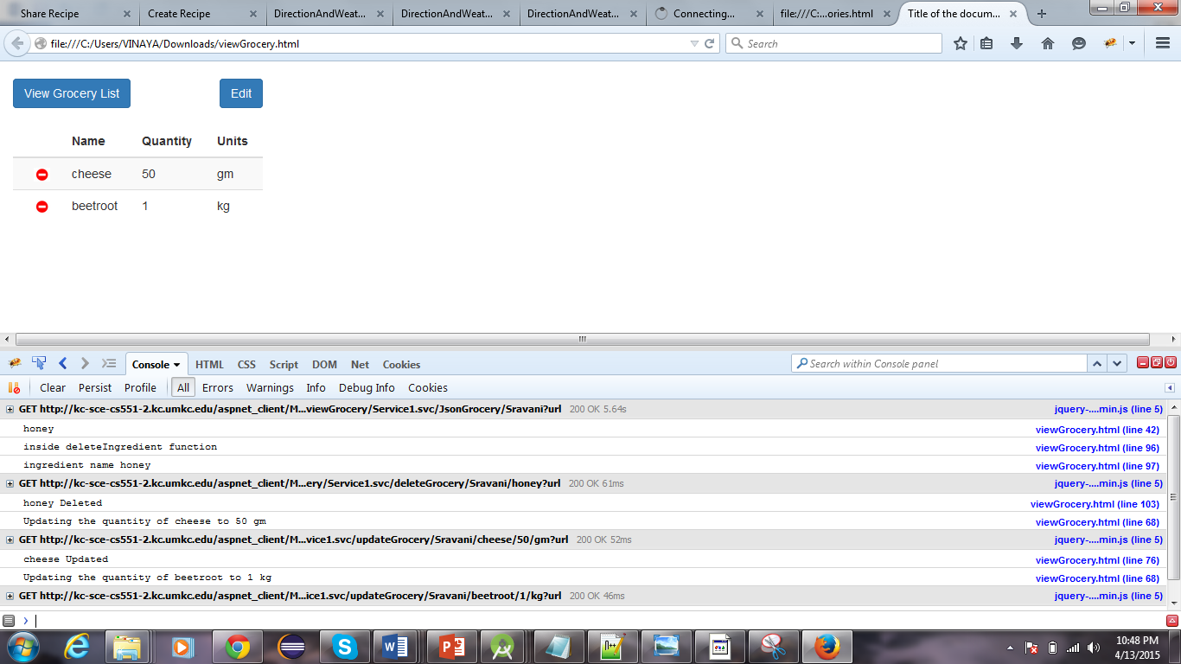

1. **ScrumDo**

We have used Scrumdo to track the progress of the project. The project development is divided into four increments. All the functions and development tasks are written as user stories.

Link: [https://www.scrumdo.com/projects/project/calorie2grocery3/iteration/122932#](https://www.scrumdo.com/projects/project/calorie2grocery3/iteration/122932)

**Screenshots for Increment#3 user stories:**

All the user stories planned for increment #3 have been successfully implemented.

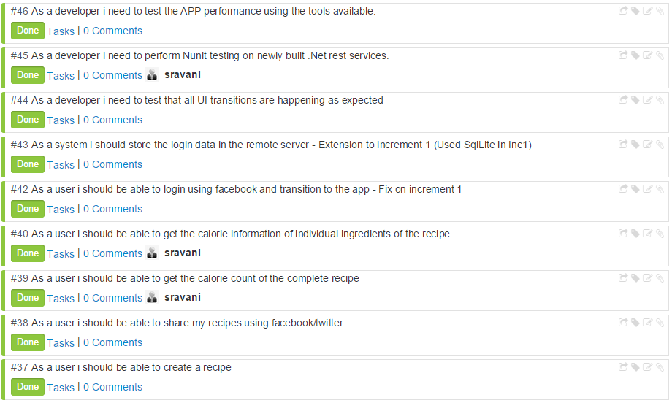

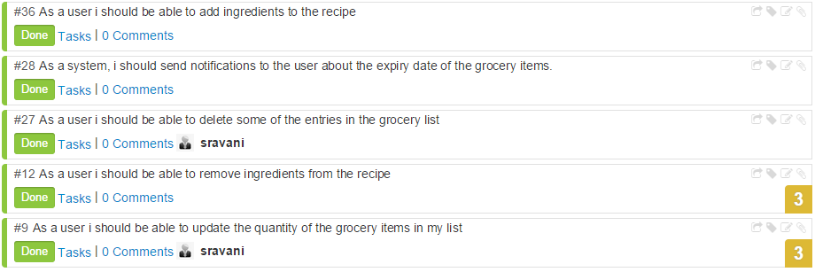

**Increment #4 user stories**

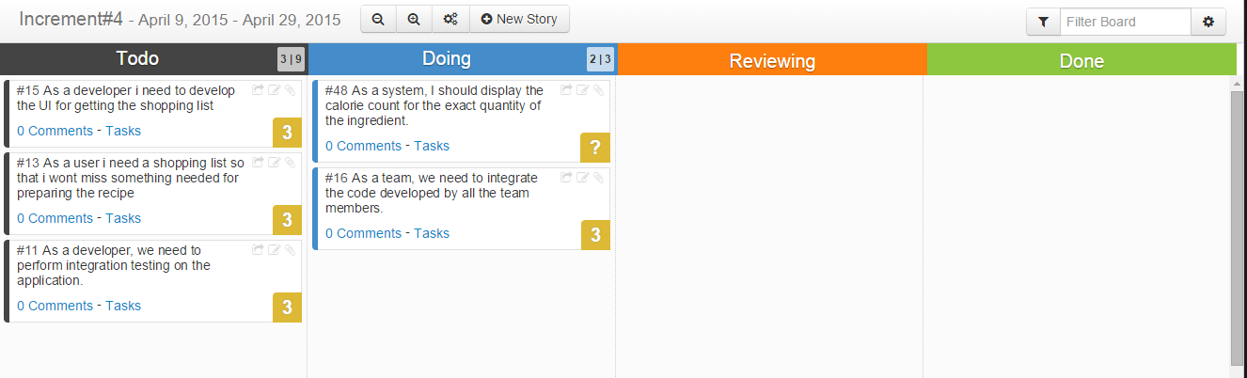

**Work Completed:**

|  |  |  |  |  |
| --- | --- | --- | --- | --- |
| **User Story#** | **User Story** | **Hours Worked** | **Team Member** | **Status** |
| 9 | As a user I should be able to update the quantity of the grocery items in my list | 10 | Sravani | Done |
| 27 | As a user I should be able to delete some of the entries in the grocery list | 8 | Sravani | Done |
| 28 | As a system, I should send notifications to the user about the expiry date of the grocery items. | 20 | Vaishnavi | Done |
| 12 | As a user I should be able to remove ingredients from the recipe | 15 | Leela | Done |
| 36 | As a user I should be able to add ingredients to the recipe | 15 | Leela | Done |
| 37 | As a user I should be able to create a recipe | 10 | Vinaya | Done |
| 38 | As a user I should be able to share my recipes using Facebook/twitter | 10 | Vinaya | Done |
| 39 | As a user I should be able to get the calorie count of the complete recipe | 2 | Sravani | Done |
| 40 | As a user I should be able to get the calorie information of individual ingredients of the recipe | 15 | Sravani | Done |
| 42 | As a user I should be able to login using Facebook and transition to the app - Fix on increment 1 | 5 | Vinaya | Done |
| 47 | As a system I need to store the recipes created by the user in the remote database | 5 | Vinaya | Done |
| 46 | As a developer I need to test the APP performance using the tools available. | 20 | Vaishnavi , Vinaya | Done |
| 45 | As a developer I need to perform Nunit testing on newly built .Net rest services. | 8 | Sravani, Leela | Done |
| 44 | As a developer I need to test that all UI transitions are happening as expected | 2 | Sravani, Leela | Done |

**GIT Hub URL:**

The Project code and documentation are uploaded to the following git hub URL:

<https://github.com/vaishnavi5054/AdvSoftEng>

**Bibliography:**

1. Reference: <http://api.bigoven.com/>

API: http://api.bigoven.com/recipes/47725api_key=dvx30p6vcIMHZWh3G1mghS88YvV6140D

This API provides two functions:

* Get Recipe
* Search Recipe

This is a REST based API. This API helps to search the recipes, display the list of ingredients. It redirects to another webpage where the user can see the recipe reviews etc… It also allows to update the grocery lists in the cloud. This supports either XML or JSON formats.

1. Reference: <https://www.recipal.com>

API: <https://recipal.com/api/v1/recipes/522>

This API helps to search and retrieve the recipes according to the scale. We can update an ingredient into the ingredient list. It also allows the user to create the customer ingredient object. The user can create a new recipe. Update an existing recipe etc…

1. Reference: <https://developer.edamam.com/>

API:https://api.edamam.com/search?q=chicken&app_id=51aba909&app_key=9fcd3aa5746d2a423a350cee3ea4d57d

This API provides services for the following:

* Nutritional Analysis API
* Recipe Search and Diet API

Here we are using Recipe Search and Diet API to search for a recipe. This API gives retrieves more information about the ingredients, the preparation time and procedure for that recipe. So, this API is more useful for our project as it gives the detailed information which helps us to import the ingredients. With the help of this API we can filter more while searching for a recipe like we can give allergic restrictions etc.